Annual Report and Accounts of
East West Railway Company Limited
2021-22

Annual report and accounts 2021-2022
For the period 1 April 2021 to 31 March 2022

Presented to the House of Commons pursuant to Section 7 of the Government Resources and Accounts Act 2000.

Ordered by the House of Commons to be printed on 15 December 2022.

HC 976



© East West Railway Company Ltd 2022

This publication is licensed under the terms of the Open Government Licence v3.0 except where otherwise stated. To view this licence, visit
nationalarchives.gov.uk/doc/open-government-licence/version/3

Where we have identified any third party copyright information you will need to obtain permission from the copyright holders concerned.
This publication is available at gov.uk/official-documents Any enquiries regarding this publication should be sent to us at contact@eastwestrail.co.uk

ISBN 978-1-5286-3832-6 E02838865 12/22

Printed on paper containing 75% recycled fibre content minimum.

Table of Contents
01.Chair’s Statement 6
02. A message from our CEO 12
03. Strategic Report 16
04.Sustainability Report 30
05. Directors’ Report 38
06. Statement of Directors’ an Accounting Officer’s Responsibilities 46
07. Governance Statement 52
08. People and Remuneration Report 64
09. Parliamentary accountability and auditor’s report 80
10. Financial Statements for the year ending 31 March 2022 90

1.

Chair’s Statement
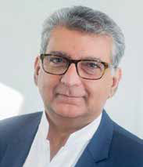

Welcome to the East West Railway Company (EWR Co) Annual Report and Accounts for the year 2021-22 - the third full year of the Company's operation.

The past year – my first as Chair – has been significant for EWR Co and for the rail sector more broadly. In May 2021, the Plan for Rail led to the proposal for 'Great British Railways', which will oversee rail transport in Great Britain and deliver the most ambitious changes to our railways in a generation.

This was followed by the Spending Review in Autumn 2021 where the government outlined its plans for UK rail investment. We also continued to face challenges associated with the Covid-19 pandemic, including imposed lockdowns affecting how we work. Under these changing circumstances, the team has worked exceptionally hard to move the Project forward and we have welcomed exciting new talent to the company, including Beth West, EWR Co's new Chief Executive Officer.

New leadership for EWR Co
My statement in last year's Annual Review highlighted the contribution of our former Chair, Rob Brighouse, to build a vision and platform for us to deliver East West Rail (EWR).

Simon Blanchflower CBE, who retired as Chief Executive Officer at the end of the reporting year (March 2022), has also played a fundamental role developing EWR.

I would like to put on record my thanks to Simon for his dedication to EWR and his lifetime of service to the rail industry. Simon brought a wealth of know-how, past experience and most of all his values to enable EWR Co to be in a great place and ready to move to the next stage. Simon can take immense pride not only in what he has achieved at EWR Co, but also in his contribution to the rail industry over a lifetime of service.

In April I was delighted to welcome Beth West as the company's new Chief Executive Officer. Beth brings a wealth of experience and notable strengths to EWR, including a successful track record in innovative construction in transport and infrastructure and, importantly, experience of working together with communities and strategic partners to deliver real improvements for local people and businesses.

Reaching our Aim
One of Beth's key priorities will be to put the company on the right path to accomplish our aim, which is to improve connections between businesses, industries and research centres. We're determined to do this in a way that's safe and accessible, better for the customer, cheaper for the taxpayer, greener for the environment and delivered quicker than before. These five outcomes guide everything we do.

Progress in 2021-22

It’s been a privilege to see first-hand the significant progress towards reconnecting Oxford, Bletchley, Bedford and Cambridge by rail. This has included:

- Delivering the Bletchley Flyover – a key part of Connection Stage 1 (Oxford to Bletchley/Milton Keynes), where engineers have saved £70m of taxpayers’ money, reduced disruption and sped-up construction of East West Rail (EWR) by using creative building techniques to build a new railway viaduct over the West Coast main line at Bletchley.

- Holding EWR Co’s second Non-Statutory Consultation (NSC) – where we asked local stakeholders and communities for feedback on emerging proposals at this early stage of the Project. I would like to take this opportunity to thank each and every person, business and organisation who provided feedback on our emerging proposals. We received more than 90,000 responses – including 190,000 individual comments – which the team is analysing carefully to help shape and refine proposals.

- Increasing engagement with our local communities, including the launch of new Local Representative Discussion Groups. These groups have been established across the route and are made up of local elected representatives to share the latest updates, address key local priorities and listen to feedback.

- More information on EWR Co’s achievements in 2021-22 is available in Section 3.4.

Looking ahead to 2022-23

The year ahead will be important for EWR as we look to progress operational preparations for Connection Stage 1 (CS1) and clarify the future direction of the wider project. In the context of rising inflation, increasing costs and pressure on public sector finances, we recognise there is uncertainty around the scheme given the dependency on ongoing policy and funding support from government.

While the context is uncertain, the case for connecting communities between Oxford and Cambridge to drive economic growth in the region remains clear. As such, in 2022-23 we will look to move forward the delivery and operational preparations for CS1 and take an agile approach to plans for the wider EWR project.

Rail services will move one step closer to being operational between Oxford and Bletchley, which is scheduled for 2025. From completing upgrades and finalising construction to recruiting drivers and station staff – there will be lots to deliver.

We also expect to make progress this year towards a Development Consent Order (DCO) application. Following feedback to the second NSC, we will look to refine proposals for the railway between Bedford and Cambridge, which will again be subject to public consultation. This will include announcing the preferred route alignment as well as a broader project update following more detailed work we’ve done to make the programme more affordable for taxpayers.

With most government restrictions being lifted, we are delighted to gradually and safely reintroduce face-to-face meetings and engagement with local residents and communities, and we’re planning to continue a regular series of community drop-in events to hear people’s individual concerns in person.

We expect other key features of the year ahead will be our ongoing collaboration with Network Rail and Great British Railways Transition Team.

I look forward to another year of progress, collaboration, consultation and delivery and I look forward to meeting lots of you at various meetings, events and site tours in 2022-23.

.

2.

A message from our CEO


Well before I joined as CEO in April 2022, I’ve been inspired by EWR Co’s clear purpose: to unlock growth and improve wellbeing for communities in the region, by transforming everyday journeys.
In this Annual Report and Accounts, I’m pleased to set out what the Company has achieved in line with this purpose over the past year as we look ahead to 2022-23.

In Section 3, we elaborate on the purpose of EWR Co: how it will strive to be innovative and efficient, which is in line with the objectives of the Plan for Rail. This section also considers the EWR Co’s highlights in 2021-22, in particular:

- Overseeing the tremendous progress of CS1 between Oxford and Bletchley.
- Engaging with communities, such as the non-statutory consultation in Spring 2021.
- Responding to the Plan for Rail in May 2021.
- Securing funding for the next 3 years in the 2021 Spending Review.
- Building capacity and capability by increasing headcount from 143 to 185 employees and by appointing our key partners Arcadis, Ardent and Jacobs.
- My team and I are currently focussed on measures to address the rising cost and supply chain pressures following the pandemic and the war in Ukraine.

Looking ahead, we’ll continue our close working relationships with Network Rail, the Department for Transport and local authorities to get the route between Oxford and Bletchley operational on time. We’re also aiming to finalise the route, operational model, and shape of the Company for the route between Bletchley, Milton Keynes and Cambridge.

Since my appointment, I’ve met many people from EWR and its key partners and I’m really impressed by the skills and professionalism of our people and what they do to support this project. I would like to thank everyone for all that they have achieved over the past year.

I would also like to take this opportunity to thank my predecessor, Simon Blanchflower, for the values that he embedded throughout EWR Co. The foundations he laid will enable us to improve east-west connections in a sensitive way that meets the needs of the communities we serve.

3.

Strategic Report

About East West Railway Company (EWR Co)
EWR Co was created as a non-departmental public body in 2018 to shake up the way major projects are delivered. It means moving away from traditional operating models and being bold in our approach to social economic development and infrastructure delivery for the communities in the Oxford-Cambridge region. The company has a clear purpose: to unlock growth and improve wellbeing for communities in the region, by transforming everyday journeys.

East West Rail (EWR) will act as a catalyst for development and growth across the region by improving its east-west transport connections.

Investment in EWR enables the creation of better jobs across the region and connects more people to employment as towns and villages will have greater access to public transport. EWR will connect industries and businesses, and support the UK in becoming a leader in global science and technology on a global stage. We strive to drive a culture of innovation across our business to increase efficiency and lead the way by establishing a model for the future of UK rail in line with the objectives of the 2021 Rail Review.

So that we can deliver a railway that increases growth, improves wellbeing and transforms every-day journeys, we've adopted an outcomes-driven approach. Our outcomes steer our decision making as well as guiding
the design of the railway. They inspire our colleagues to contribute to our ambitions collectively.

We'll deliver a railway that is:
- Safe and accessible
- Better for the customer
- Cheaper for the taxpayer
- Greener for the environment
- Delivered quicker than before

These outcomes guide EWR Co through the lifetime of the EWR Project and are the basis on which we measure future success.

How the Project will be delivered
EWR Co, the Company, is responsible for integrating the entire EWR Project. We take a forward-focussed approach that makes sure everything needed to achieve our purpose and outcomes is considered every step of the way. All decisions are measured and assessed based on their impact across all of our outcomes. This is what we refer to as the Enterprise Approach and it enables us to integrate everything we need to deliver EWR.

We consider three elements of the railway to be inextricably linked and the integration between them is key. Making sure that these elements are connected and work in harmony is critical to the success of our Enterprise Approach. The three elements are:

- The railway solution needed to deliver these outcomes: the technology and physical materials we need to achieve our outcomes.

- The organisation needed to deliver our outcomes: EWR Co, our current partners, and our future partners.

- The environment within which the Enterprise exists that is needed to deliver the outcomes: everybody that interacts with EWR currently and in the future, e.g. government departments, our customers, the communities we serve, our partners, the wider rail community, regulatory bodies, and the EWR Co team.

To succeed in mapping out these elements and understanding what the business needs to achieve them, we’re developing a picture of what the railway will look and feel like when it is operational, where we will have achieved a described level of mature performance for all of our outcomes. This will give us a single source of information to help make the right choices.

The structure of EWR Co
During 2021-22 EWR Co was structured around five Directorates, and a small set of professional service functions that represent groups of
specialist capabilities, which support the achievement of our objectives.

The five core Directorates are:

Strategy and Sponsorship
Owns the definition and delivery of the Company’s strategy, to deliver the objectives established by the Strategic Sponsor (DfT) and the needs of our future customers.

Corporate Services
Manages the Company’s finances and associated financial planning, management, accounting and control processes, as well as procurement and IT activity. It provides the oversight and financial guidance necessary to help protect value for money in programme delivery and operations management.

Engineering
Owns the development and maintenance of appropriate engineering standards. This includes establishing asset management strategies, monitoring design compliance and approving designs through a review and assurance process.

Programme Delivery
Assumes all delivery obligations for EWR, ensuring consistency of delivery, ongoing learning of delivery lessons, and continuous improvement encompassing:
  - Connection Stage 1 (CS1 – Oxford to Milton Keynes): Oversees and assures the work delivered by Network Rail through the EWR Alliance (who are taking forward the construction of this section) to time, cost and quality requirements.

  - Connection Stage 2 (CS2 – Milton Keynes to Bedford) & Connection Stage 3 (CS3 – Bedford to Cambridge): Leads and manages the delivery of this section including the development of the project design and the Development Consent Order (DCO).

Customer Services
Is responsible for ensuring the customer is at the forefront of decision making and driving industry leading customer experience through customer-facing teams. It owns the integrated operations strategy for the network and train operations and is responsible for setting out how the Company will meet industry good practice.

The organisation is further supported by the following professional services functions:

Health, Safety, Security and Quality
Establishes the health and safety (H&S) systems and processes for the organisation that meet or exceed regulatory requirements and industry best practice. This includes setting standards for physical security.

People & Culture
Establishes and implements human resource (HR) strategies and policies. Recruits, develops and supports staff retention through organisational and geographic change, and puts in place the mechanisms for managing the performance of our people.

General Counsel & Company Secretary
Provides legal advice and ensures EWR Co is compliant with all relevant legal and regulatory requirements while delivering our mission.

Achievements during 2021-22
The financial year to 31 March 2022 was a critical year for EWR Co and we made significant progress in the delivery of the Project. In May 2021, the publication of the Plan for Rail, and the creation of the Great British Railways Transition Team, saw the government signalling support for East West Rail. This was followed by a positive Spending Review in Autumn 2021 where the government re-committed funding for EWR in the context of wider UK rail investment. We ended the year by welcoming our new CEO, Beth West.

Key highlights of the year include:
- Our second Non-Statutory Consultation (NSC) which took place on the route between Bletchley and Bedford, and Bedford and Cambridge. We were pleased by the engagement shown through the consultation with more than 90,000 individual responses and 190,000 comments. This will support our plans for the Statutory Consultation.

- As well as the NSC, we grew our engagement with communities by establishing Local Representatives Discussion Groups. We also appointed a Head of Inclusion demonstrating our commitment to EWR for All.

- We progressed Connection Stage 1 (Oxford to Bletchley/Milton Keynes) with the successful delivery of the Bletchley Flyover, completed by the EWR Alliance, over the Easter Bank Holiday weekend. We also engaged our communities further, opening our development at Winslow Station to local residents.

- We onboarded key partners – Arcadis as Commercial Partner, Ardent as Land and Property Partner and Jacobs as Programme Partner – who will support us through the delivery of the Development Consent Order (DCO) and into the next delivery phase. The onboarding of these partners enabled planning to continue for Connection Stages 2 and 3 (onwards to Cambridge).

- We made critical progress on our commitment to the environment. We outlined the vision for a net zero carbon railway, as well as pledging to create new habitats to create biodiversity net gain.

- Over the course of the year, we continued to enhance our capabilities and mature as a company. EWR Co grew from 143 to 185 employees during 2021-22. We focussed investment on the strengthening of our core capabilities in programme management, customer experience and operational readiness ahead of CS1’s entry into service.

Measuring performance 2021-22
We manage performance through monthly programme and corporate reporting, which enables the EWR Co Board and DfT to regularly review progress. As in previous years, we use a Corporate Performance Scorecard to review progress as agreed with the DfT EWR Shareholder Board. This is now aligned to our five outcomes and includes a range of corporate and programme KPIs and milestones.

During 2021-22, we made significant progress in moving forward the EWR programme; however, significant external challenges required us to change focus in the second-half of 2021-22. The outcome of the 2021 Spending Review, paired with a shift in policy direction from Government regarding the Oxford-Cambridge Arc, has meant that for the latter half of 2021-22, EWR Co has focused on reviewing and understanding how East West Rail can best facilitate economic growth and meaningful connections across the region whilst delivering the best value to the taxpayer.

This shift has resulted in a significant impact on the milestones which we set in April 2021. The impact on milestones has been both direct, such as the decision to defer the Preferred Route Alignment Announcement, and indirect – where focuses have been re-prioritised. In light of the programme changes experienced by the company during 2021-22, we have assessed its Corporate Scorecard to exclude the milestones and metrics which were directly and indirectly impact by this change in direction.

The final end of year score for EWR Co was agreed at 44%. This score includes only the business-as-usual performance indicators that were identified for the scorecard, as well as milestones not impacted by the changes that occurred within the year. Our most high-performing area related to the ‘Cheaper for the Taxpayer’ outcome. As shown in section
3.8 and like in previous years, we came under budget. Whilst most of this was due to fiscal prudence, a portion of this under-spend was due to rescheduling of works into 2022-23 and deferring the period in which we procured our Technical Partner.

In this year’s Infrastructure and Projects Authority Annual Report on Major Projects1, EWR received Delivery Confidence Assessment ratings for the CS1 and CS2&3 schemes of amber and red respectively. The amber rating for CS1 reflects that the project is progressing well, and while there are some risks to delivery, these are being monitored and mitigated, and the project is on schedule to deliver services by 2025. For CS2&3, work is in progress to refresh the business case and test the options for the future development

of the scheme. We anticipate that once this is complete, we will update our programme and expect the rating for CS2&3 will improve.

Priorities and plans for 2022-23
The year ahead will be a critical year for EWR Co, particularly as CS1 moves closer to operations in 2024-25, and we’ll look to develop plans for CS2&3. This will be achieved whilst working closely with the Great British Railways Transition Team to develop the future operating model across the network. Recognising the current context, and subject to any decisions made by the new Government, we will be agile in the planning and delivery of our priorities in 2022-23.

Early in the year, we’ll aim to finalise the operating model for CS1. We’ll establish key contracts, such as maintenance, and ensure that by the end of the year all necessary contractual arrangements for operations, such as land access, are in place. The Alliance will complete Bletchley High Level Station and construct all necessary earthworks safely and securely.

Driver recruitment will start towards the end of the year. We will finish the year on track for entry into service – on time and under budget.

We expect to continue planning for CS2&3 supported by our partners. We’ll continue to progress the business case emphasising the growth opportunities for the region.

Our community focus will continue to be at the heart of EWR Co. We’ll plan to increase our community engagement as we move closer to finishing CS1 and finalising plans for CS2&3.

To support this increase in delivery, we’ll continue to mature EWR Co as an organisation. This will include the procurement of Partners to build the capacity and capability of the company to meet our ambitions in a timely manner.

Key strategic risks facing us
Central government faces difficult decisions as pressure mounts on public sector finances, caused by rising inflation, the legacy of a pandemic and a war in continental Europe. The construction sector is facing supply chain shortages, which is also driving up costs.

Our top strategic risks that may affect EWR Co’s ability to deliver against its outcomes and plans include:

- The financial impact on the scheme affordability due to rising inflation, the legacy of a pandemic, lack of supply chain capability/ capacity (materials and resources) and the war in continental Europe;
- Uncertainty around the future role of EWR Co in light of the Plan for Rail; and
- Uncertainty of government policy on the Oxford-Cambridge Arc and potential impact on support to the EWR scheme.

These risks are under careful review and management, through ongoing programme development activities, communication and engagement with stakeholders and government. Further information on the identification, mitigation and control of risks that we managed during 2021-22 can be found in Section 7.9.

Review of financial performance in 2021-22
Our financial performance for the year ending 31 March 2021 is detailed in the financial statements in Section 10.

During 2021-22, EWR Co was entirely funded by grant in aid, or capital contributions, from DfT. No income was generated from any other source. In this financial year, EWR Co incurred a combined capital and resource expenditure total of £74.7m (2020-21: £37.3m2):

  - Capital expenditure was £0.3m, which comprised the purchase of IT assets (as shown in Note 5 to the Financial Statements).

- The slight difference between this value and the resource and capital values is caused by a rounding difference.

  - Resource expenditure was £74.4m, compared with £35.7m in 2020- 21 and £22.0m in 2019-20. The year-on-year rise is mainly due to the increasing use of professional services going from £9.4m in 2020-21 to £30.8m in 2021-22, consultancy services rising from £7.5m to £11.9m, and staff costs growing in line with rising headcount from £12.7m to £20.1m.

  - We use consultancy services to advise on policy and programme development, and we engage professional services to implement policies and programmes. Our use of professional services tends to be focussed on non-permanent specialist tasks, and it allows us to maintain flexibility over our staff mix. Section 8.24 provides more information on the role of consultancy at EWR Co.

  - Professional services increased significantly during 2021-22 as we used more third parties to help us prepare. Our Programme Partner, Jacobs, has provided us with capacity and specialist capability to support us through the remainder of its development phase. Jacobs also supplies engineering and systems assurance support to augment the capabilities of our in-house engineering team. Arup supported us with the non-statutory consultation process and with technical expertise until we appointed the Technical Partner. Our Land and Property Partner, Ardent, helped us by arranging the access and consents needed to carry out studies and surveys.

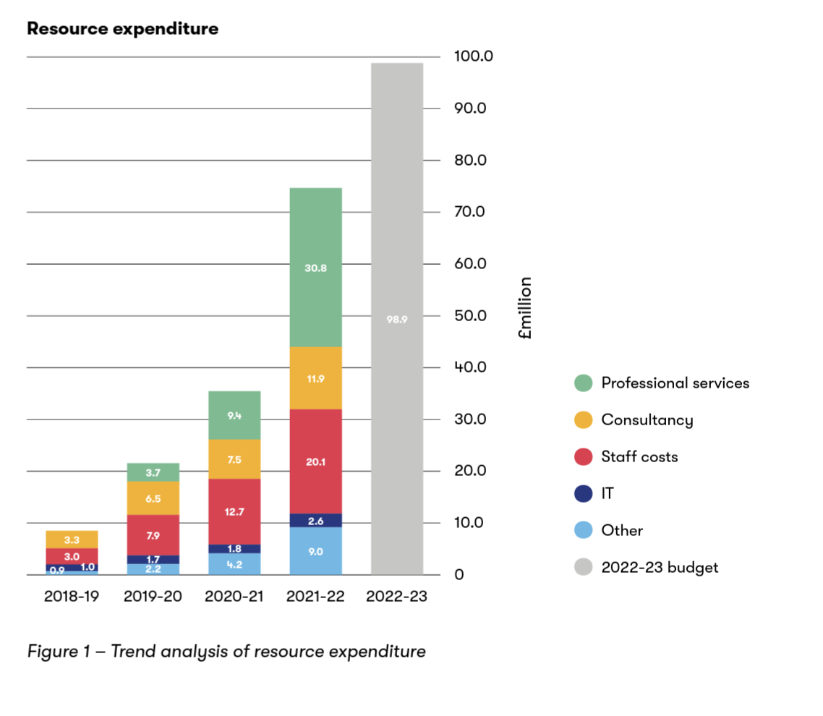
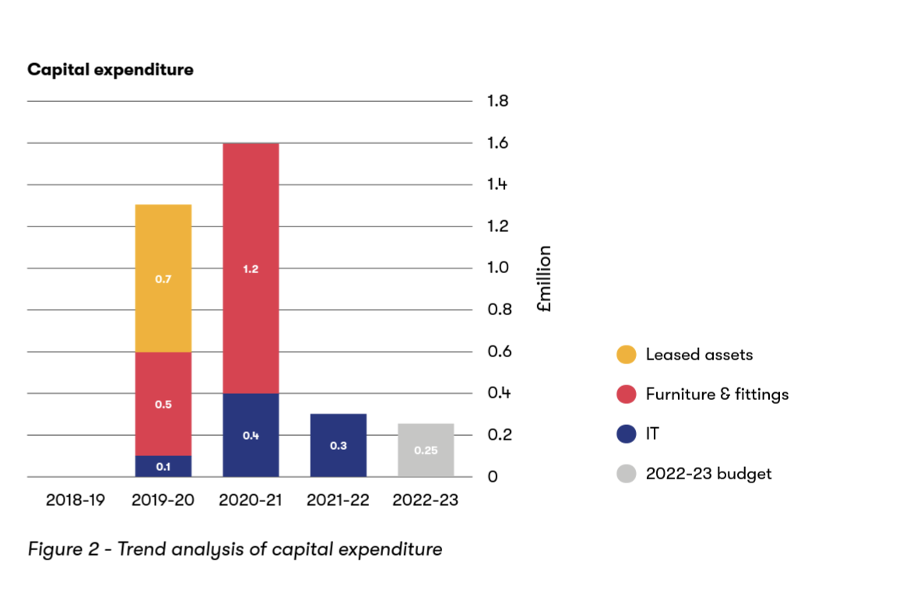

109% growth in expenditure is matched by increases in related lines of the balance sheet:
- The amount of VAT that can be recovered from HMRC has increased by 93%.
- The amount payable to others has increased by 72%. Creditor days has reduced from 55 to 48 days because suppliers are billing EWR Co sooner and we are settling the bills more promptly.

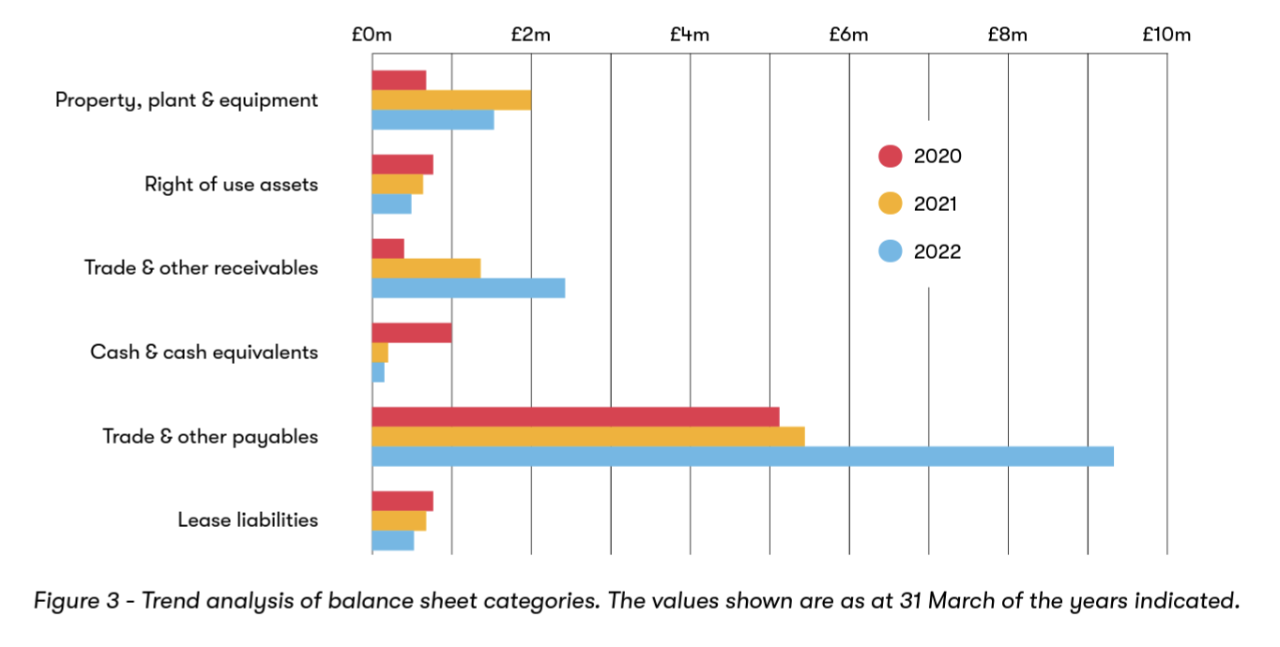

HM Treasury’s framework for government spending splits transactions into 4 high level budgets, of which EWR Co has been allocated budgets for 2 out of the 4 categories. Our budget allocations can be found in DFT’s section of the Estimates, which are approved by Parliament3. The table below shows how EWR Co performed against the budgets in 2021-22.
All figures in £m
Budget
Outturn
Underspend Reasons for underspends
Budget category4

Resource DEL | 83 | 74 | 9 | Delays to procuring a key supplier, see section 3.5
Resource AME | 5 | - | 5 | Provisions for legal and other challenges were not required
Capital DEL | 0.3 | 0.3 | -
Total expenditure | 88 | 74 | 14 | As above
Grant in Aid | 85 | 71 | 14 | As above

Table 1 – Performance against budgets approved by Parliament 2021-22

Non-financial information

Human rights
We know that empathy and consideration need to be shown to all parties within our supply chain, respecting and protecting human rights. As an employer, we must ensure no one is exploited. We have policies in place to ensure compliance with legislation, in order to protect all those who work for, or with, EWR Co and those in the communities where we operate. We refuse to do business with any individual, company or organisation that fails to uphold the standards and principles of basic human rights, or which give EWR Co cause for concern. We have adopted procedures which aim to ensure modern slavery does not occur in our business or supply chains and expect the organisations with whom we do business with to adopt and enforce policies to comply and support all applicable laws and legislation, including the Modern Slavery Act 2015.

- HC 1152 – Central Government Supply Estimates 2021-22: https://assets.publishing.service.gov.uk/government/uploads/system/uploads/ attachment_data/file/1056679/E02711189_HC_1152_Supply_Estimates_21-22_Web_Accessible.pdf
- Definitions for these budget categories can be found in DfT’s Annual Report & Account: https://www.gov.uk/government/collections/dft- annual-reports-and-accounts

Anti-corruption and anti-bribery
We are committed to operating in an open and honest way, with policies and procedures in place to promote anti-corruption and anti-bribery.

All colleagues are made aware of the policies when joining EWR Co. Team members also complete mandatory online training annually. Our Speak Up whistleblowing policy makes it clear that any individual raising an issue internally or externally will not be at risk of losing their job, or suffering any form of retribution or harassment as a result. We consider the whistleblowing arrangements to have been effective during 2021-22. During this period no formal cases were raised.

Community engagement
We’re building a railway which will connect people, places and communities. Listening, understanding and engaging with those that EWR will serve is key to delivering a successful project for everyone.

Between 31 March and 9 June 2021, we carried out a second non-statutory consultation to hear feedback on our proposals. It was important to us that communities and stakeholders had the opportunity to share their views.

And while the pandemic prevented us from face-to-face engagements, we continued discussions by hosting online meetings during this period. We were delighted to achieve lots of engagement with over 190,000 individual comments.

Whilst we process and properly review all of the feedback, we remain committed to being approachable. That means listening and responding to ongoing requests, comments, and concerns from communities across the route. Moving forward, we are pleased to be reintroducing face-to- face engagement in line with the easing of Covid-19 restrictions, keeping communities well informed about the project.

With a view to better understanding the outlook and aspirations of our communities, we’ll continue to conduct research in order to provide effective local public transport links and a holistic approach that will support growth in communities across the route.

As the EWR project evolves, we’ll continue to build meaningful relationships with our communities and plan for more engagement opportunities in the near future.

Going concern
East West Rail is part of the government’s rail agenda and in accordance with the aims of the Department for Transport (DfT). As our sponsor, the Project is funded entirely by DfT. The company’s status is therefore reliant on the continued policy and financial support of the Department and wider government, as reflected elsewhere in this report. While discussions on project scope are natural for any major project, support for the company’s continued activity has been demonstrated recently in the following ways.

EWR Co was granted permission by DfT in 2020-21 to sign a range of commercially binding contracts extending into future years.

The Senior Responsible Owner for East West Rail at DfT, Cavendish Elithorn, wrote to EWR Co’s CEO on 11 February 2022 confirming that HM Treasury and DfT had agreed to fund EWR Co throughout the next Spending Review period (2022–2025). Parliament has approved EWR Co’s budget for 2022- 23 as part of the Main Supply Estimates process. These are shown in Figures 1 and 2 in Section 3.8 above.

The Government’s commitment to EWR, confirmed by the Autumn Statement in November 2022, reflects how important this project is for both economic growth and the quality of life in this area. Following the Chancellor’s commitment, we are now able to move forward with our plans to deliver a faster, more sustainable and affordable way to travel that links people to their jobs, families and friends.

Consequently, it is considered appropriate to adopt a going concern basis for the preparation of the financial statements for 2021-22.

Beth West, CEO

The Strategic Report is signed by Beth West, Chief Executive and Accounting Officer, on behalf of the EWR Co Board, on 12 December 2022.
4.

Sustainability Report

Our vision
Our sustainability vision is 'to be a sustainable transport business and promote sustainable communities'. The vision supports our purpose and is underpinned by three of our outcomes: greener for the environment,
better for customers, and safe and secure. Three core capabilities feed into our sustainability strategy: environmental sustainability, social value and inclusion.

EWR Purpose
To increase growth and improve wellbeing for communities in the Oxford-Cambridge Arc, by transforming their everyday journeys
EWR Sustainability Vision
To be a sustainable transport business and promote sustainable communities
EWR Outcome | Greener for the Environment | Better for Customers | Better for Customers and Safe & Secure
Capability | Environmental Sustainability | Social Value | Inclusion
Vision | To provide and promote cleaner, greener travel solutions | To improve people's lives - starting now | To embed Inclusion in all we do
Strategy Pillars / Strategic Objectives | Biodiversity Net Gain & Natural Environment | Inclusive Growth | Inclusive Culture
 | Carbon | Education and Skills | Inclusive Design and accessibility
 | Circular Economy | Health, Safety & Wellbeing
 | Climate Resilience | Equality, Diversity and Inclusion
 | Community Impact
 | Cultural Heritage and Landscape
Key Activities | - Net Zero Carbon Action Plan  - Preliminary Environmental Information Report  - Scoping Report (DCO)  - Environmental Management System (ISO 14001) | - Setting strategy and designing social value programmes  - Providing leadership & coordination of SV interventions across the Enterprise  - Driving the right behaviours and culture | - Strategy implementation  - Maximise the opportunity to embed inclusion across the Enterprise  - Provide subject matter expertise to build a Customer Vision with a focus on Inclusion  - Build a culture of competence about Inclusion and equality impacts

Table 2 – Our approach to sustainability

Greener for the environment
We’re committed to protecting the environment through the prevention of pollution, compliance with government objectives and continually improving our environmental performance.

It’s critical that the railway is designed, constructed, operated and maintained in an environmentally responsible way which minimises negative environmental impacts, is climate resilient and realises opportunities for improvement. Embedding this outcome into the Enterprise Strategy means the success of the project is directly related to environmental performance. Our staff, partners and supply chain are engaged and committed to protecting the environment.

Our environmental sustainability vision to provide and promote cleaner, greener travel solutions, delivers the overarching direction for our design.

We’re implementing our Environmental Sustainability Strategy, which covers six key environmental pillars and their associated strategic objectives.

We’ve identified indicative environmental sustainability goals for when the network is fully operational, these are under discussion with DfT. They provide clarity for development of our interim objectives, metrics, measures and KPIs, and progressed via implementation plans.

Our functional design requirements will aim to ensure we are environmentally sustainable by design.

ES Vision: To provide and promote cleaner, green travel solutions
ES Strategy Pillar | Strategic Objective | Goal (operational network)
Biodiversity and the natural environment | Protect and enhance biodiversity through the maintenance of healthy ecosystems (wildlife habitats, soil, land and water resources) | Maintain a minimum percentage of biodiversity net gain (to be agreed with DfT)
 |  | Existing habitats within the corridor enhanced and more connected
Carbon | We minimise our carbon footprint, through advancing low carbon design, construction and operation, to be a net zero carbon railway; | Pending decision on traction power
Circular economy | Implement circular economy principles to optimise resource value, minimise impact and preserve resources | A railway that supports a collaborative circular economy
Climate resilience | Consider current and future climate change impacts to maintain the value of assets throughout the project lifecycle and ensure business and service functionality | A railway that is resilient now, and in the future, over the lifetime of the assets taking account of the effects of climate change
Community impact | Be a good neighbour by avoiding significant impacts on health and quality of life, and contributing to the wellbeing of | A railway that promotes access to open space
 | our communities | No 'Category A - Significant environmental incidents'
Cultural heritage and landscape enhancement | Enhance the quality of landscapes and townscapes, whilst maintaining the historic environment | A railway that enhances the quality of landscapes, townscapes and visual amenity  A railway that maintains or enhances the historic environment resource

Table 3 – Our environmental sustainability approach

Carbon
A robust whole-life carbon management process is essential. We've developed a plan to deliver a net zero carbon outcome that aligns with DfT's requirements and industry standards, such as PAS 2080: Carbon Management in Infrastructure. Carbon is integrated into all our business, strategy and design processes, and our preliminary carbon assessments are updated whenever we need to inform a decision. We aim to power our trains sustainably in the long-term.

Defining what net zero carbon entails for an infrastructure project is not straightforward, and will require a large amount of decisions, stakeholder engagement and analysis to land on a suitably challenging, yet feasible, target. We are currently developing the Project's carbon baseline, which will iterate over time as the design develops and strategic decisions are made to inform our net zero carbon target, which we'll announce once all funding is secured. In the meantime, driving down carbon is central to everything we do.

All our carbon data and the net zero carbon target is externally verified and follows recognised principles for any offsets.

Biodiversity & the natural environment
We are working with DfT to determine and agree our programme target for biodiversity net gain.

Preparing an environmental assessment
To prepare for our planning submission (Development Consent Order), we're progressing an Environmental Impact Assessment (EIA) Scoping Report, which will define the scope and method to be used for the EIA. We're working closely with our stakeholders, including local community groups, environmental bodies and local authorities, to identify and understand their needs and expectations, and have completed Non- Statutory Consultations.

We're continuing to collect baseline information, working with local interest groups, records centres and archives, as well as extensive environmental survey work. The survey work has included a range of activities including farm business interviews and surveys of the landscape, air quality, heritage, traffic and ecology.

We are liaising with our partners at East West Rail Alliance to monitor performance, share best practice, discuss lessons and identify whether there's a need to establish an assurance role.

Estates and facilities reporting
Our estates and business travel processes are managed in a sustainable way, utilising the principles of the Greening Government Commitments (GGC). The GGC set out high level targets for central government entities to deliver reductions in operational consumption and waste, standards for transparent reporting on sustainable procurement, and key sustainability areas including biodiversity and climate change adaptation.

Company data for the years 2020-22 has been impacted by the pandemic, where home-working has reduced office use and business travel significantly. DfT is working to develop a formula which enables home- working datasets to be collated and appropriate targets determined.

Carbon emissions
The table below details tonnes CO₂e emissions associated with our office energy consumption, powered by the Milton Keynes district heating scheme, and corporate travel.

Scope 2 emissions have substantially increased. This is due to inclusion of 5.1% of the business estate communal energy and EWR metered office energy. EWR office use is 45,963 kWh; equivalent to 282 kWh per employee.

Scope 3 emissions have also increased. This reflects the availability of rail travel data and increased attendance at in-person meetings.

2020-2021 2021-2022
Gross emissions | Scope 1 Direct emissions | tonnes CO₂e | - | -
 | Scope 2 Indirect emissions | tonnes CO₂e | 8.42 | 17.55
 | Scope 3 Business travel | tonnes CO₂e | 1.84 | 3.02
 | emissions | tonnes CO₂e
 | Total emissions | tonnes CO₂e | 10.26 | 20.57
Related consumption | Estates electricity | kWh | 36,113 | 86,454
data
data | Electricity usage per person | kWh/FTE | 36.11 | 530
 | Private & hire car usage | Road miles | 3,260 | 2,214
 | Rail | km | - | 40,436
Financial indicators | Electricity utility costs | £000 | 4 | 14
 | Business travel costs | £000 | 13 | 13

Table 4 – Our carbon emissions

Waste data
Our corporate waste data was collated for the first time during 2021-22. The data presented below is in accordance with our contract terms with the office landlord. EWR Co assumes responsibility for 5.1% of all waste produced at the business park. In real terms our contribution has been minimal due to the impact of home-working and a shift to more flexible working patterns.

Waste disposal type | Weight (tonnes) % Total Waste
Energy (combustion)  Recycling | 1.62 38
Energy (combustion)  Recycling | 2.59 62

Water consumption
The table below shows water consumption at our office in Milton Keynes. It’s a multi-tenanted site and our estimated use is based on 7.5% of the estate water volume, as stated in the lease.

2020-21 2021-22
Non-financial indicators | Estates water | m3 | 0.767 | 662
Non-financial indicators | Usage per person | m3/FTE | 0.008 | 4.06

5.

Directors’ Report

The Board and its committees
The Board sets EWR Co's strategic direction and oversees the management of performance and risk, financial management, planning, and overall governance.
It's supported by the Investment Committee, the Audit and Risk Committee, the Remuneration and Nomination Committee, and the Safety, Health and Environment Committee. The attendance of the Board Directors at these Committees is set out in Section 7.5 of the Governance Statement.

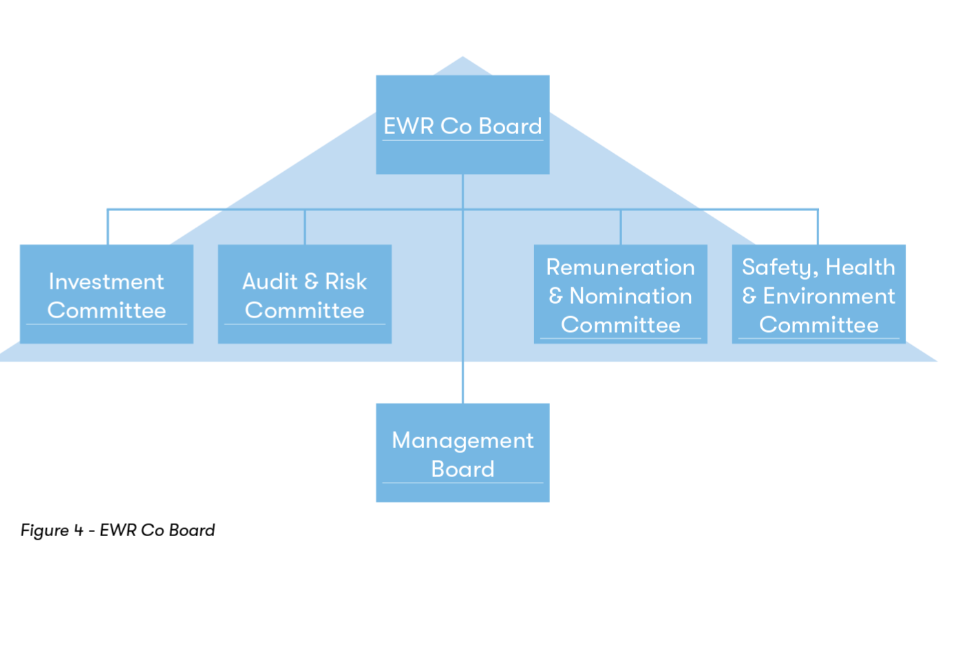

Board members
On 31 March 2021 the Board was comprised of the following members:

Neil Sachdev
Non-Executive Chair of the Board Appointed on 19 April 2021 Investment Committee
Safety, Health and Environment Committee
Simon Blanchflower CBE
Chief Executive Officer
Appointed on 3 December 2018 Remuneration and Nomination Committee Investment Committee
Safety, Health and Environment Committee
Anne Baldock  Non-Executive Director  Re-appointed on 1 February 2022 Audit and Risk Committee Chair  Remuneration and Nomination Committee Investment Committee  Senior Independent Director | Dyan Crowther OBE  Non-Executive Director  Re-appointed on 1 February 2022  Safety, Health and Environment Committee Chair Remuneration and Nomination Committee  Audit and Risk Committee
Simon Murray  Non-Executive Director  Re-appointed on 1 February 2022 Investment Committee Chair Audit and Risk Committee  Safety, Health and Environment Committee | Lynette Ryals  Non-Executive Director  Appointed on 1 November 2020  Remuneration and Nomination Committee Chair Audit and Risk Committee  Investment Committee
Joanna Whittington  Non-Executive Director  Appointed on 1 October 2020 Remuneration and Nomination Committee Audit and Risk Committee | James Norman  Corporate Services Director Appointed on 22 July 2021 Audit and Risk Committee Investment Committee

Table 5 - Board members

Neil Sachdev joined the Board as Chair with effect from 19 April 2021, taking over from Rob Brighouse who stood down on 18 April 2021. Simon Blanchflower retired on 31 March 2022. The fees of all Board Directors are set out in Section 8.23 of the People and Remuneration Report.

Directors’ attendance at Board
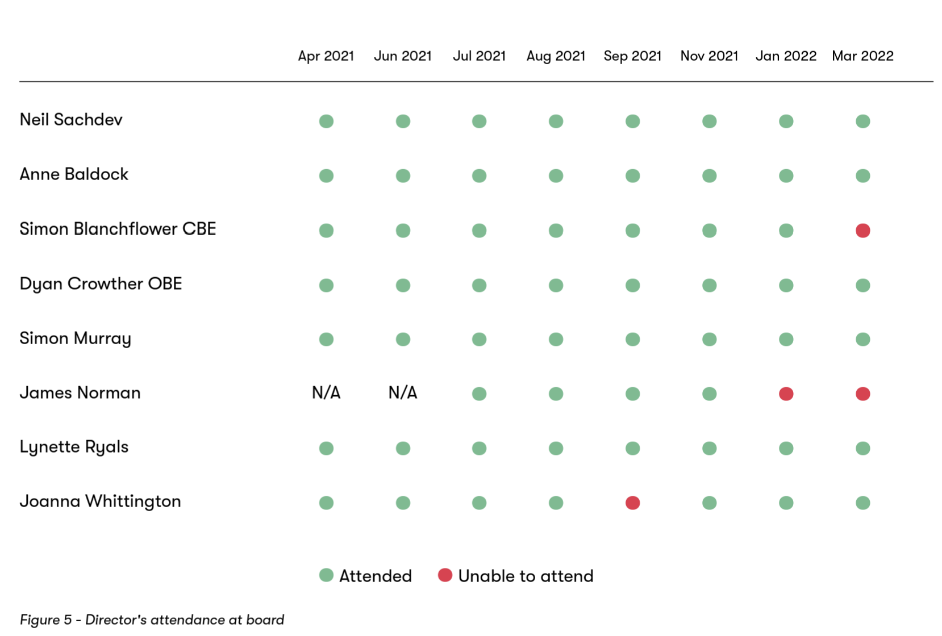

Cavendish Elithorn, the Senior Responsible Owner for EWR at DfT, attended four of the EWR Co Board meetings in 2021-22 as an observer. He held no voting rights.

Personal data-related incidents
No protected personal data-related incidents have arisen which have required reporting to the Information Commissioner’s Office.

Remuneration report and Governance Statement
The Remuneration Report (Section 8) and Governance Statement (Section 7) are required under the FReM and form part of the Directors’ Report. The Governance Statement addresses EWR Co’s risk and control framework.

Conflicts of interest
Procedures are in place to ensure Directors comply with their duties in relation to conflicts of interest. Board Directors are obliged to provide details of any direct or indirect interests that conflict with or may conflict with EWR Co’s interests. These are recorded on a register of interests
and updated as required. At the start of every Board and sub-committee meeting, the Chair asks for any interests to be declared.
At the date of this report, the following key potential conflicts of interest have been declared:
- Neil Sachdev, non-executive chair of the Board, is non-executive director of Network Rail’s Property Supervisory Committee.
- Lynette Ryals, non-executive board member, is Pro-Vice-Chancellor of Cranfield University.

Political and charitable contributions
During the year, EWR Co made no charitable or political donations.

Other material issues
Since the end of the financial year, Beth West has joined EWR Co as CEO on 1 April 2022. The Corporate Services Director, James Norman, left EWR Co on 29 April 2022. The Board appointed Ian Davis, Head of Finance, to act as Corporate Services Director until a permanent replacement starts.

Other than those matters, there have been no material events that have, or are expected to, affect EWR Co since the end of this reporting period (31 March 2022).

Paying suppliers
Government policy on prompt payment is that in-scope organisations, such as EWR Co, should pay 80% of all undisputed invoices within 5 days, with the remaining undisputed invoices paid within 30 days. EWR Co was praised for paying suppliers on time in the February 2022 edition of the New Civil Engineer magazine5.\

2019-20 |  | 2020-21 | 2021-22
Undisputed invoices paid within 5 days  Undisputed invoices paid within 30 days | 61% | 90% | 94%
 | 97% | 99% | 98%

Table 6 – Trend analysis of invoices paid on time

Dividends
EWR Co does not generate a profit and receives all its funding from its shareholder. Therefore, no dividends will be distributed for the year ending 31 March 2021 or in the foreseeable future.

Contingent liabilities
EWR Co did not recognise any contingent liabilities on 31 March 2022.

Auditor
EWR Co continued to appoint the Comptroller and Auditor General (National Audit Office) during the year under the Companies Act 2006. An audit fee of £72,000 (excluding VAT) was charged, and no non-audit work was carried out by the NAO.
The Directors’ Report is signed by Beth West, Chief Executive and Accounting Officer, on behalf of the EWR Co Board, on 12 December 2022.

- https://www.newcivilengineer.com/latest/almost-1000-invoices-were-paid-late-by-hs2-last-year-21-02-2022/

6.

Statement of Directors’
and Accounting Officer’s Responsibilities

Directors’ responsibilities under the Companies Act
Company law requires the Directors to prepare financial statements for each financial year.

Directors are required to follow the principles of the Companies Act 2006 and International Financial Reporting Standards (IFRS). In line with the framework document, they’re also required to make additional disclosures under HM Treasury’s financial reporting manual (FReM) where this would improve understanding.

Under company law, Directors must not approve the financial statements unless they’re satisfied that they are prepared on an accrual basis. They must give a true and fair view of EWR Co’s state of affairs, and of EWR Co’s surplus or deficit, application of resources, changes in equity and cash flows for that period.

In preparing financial statements, the Directors are required to:
- Select suitable accounting policies and apply them consistently.
- Make judgments and estimates that are reasonable and prudent.
- State whether applicable accounting standards as set under IFRS have been followed, subject to any material departures disclosed and explained in the financial statements.
- Prepare the financial statements on the going concern basis, unless it’s inappropriate to presume that EWR Co will continue in operation.

The Directors are responsible for keeping proper accounting records that disclose at any time, and with reasonable accuracy, the financial position of EWR Co, and enable them to ensure that the financial statements comply with the Companies Act 2006 and the IFRS. They are also responsible for safeguarding EWR Co’s assets and for taking reasonable steps to prevent and detect fraud and other irregularities.

Accounting Officer’s responsibilities
As a Non-Departmental Public Body of the Department for Transport (DfT), EWR Co also requires an Accounting Officer to be appointed. The Permanent Secretary of the DfT appointed Simon Blanchflower as the Accounting Officer for EWR Co. He shared, on an individual basis, many of the Directors’ responsibilities listed above, as well as being accountable to Parliament for:
- Safeguarding the public funds which have been allocated.
- Ensuring propriety and regularity in the handling of those public funds.
- The day-to-day operations and management of EWR Co.
- Satisfying themselves that the Annual Report and accounts are fair and balanced.
- Taking responsibility for the judgements used in the accounts.

The Accounting Officer is required to ensure that EWR Co is run based on the governance, decision making, and financial management standards set out in HM Treasury’s Managing Public Money.

The Governance Statement within this document sets out how these responsibilities have been discharged in the year 2021-22.

The Accounting Officer is responsible for signing the financial statements, supported by the Board and Audit and Risk Committee. They’re also responsible for ensuring that proper records are kept, and that the accounts are properly prepared and presented in accordance with Companies Act 2006. Since responsibility as Accounting Officer transferred from Simon Blanchflower to Beth West on 1 April 2022, Beth has considered verbal and written assurances from Simon. The Accounting Officer also signs the Strategic Report, the Directors’ Report, and the Remuneration and Staff Report, on behalf of the Board following Board approval.

Statement by the Accounting Officer:
I am able to confirm that, as far as the Directors and I are aware, there is no relevant audit information of which the auditors are unaware. The Directors and I have taken all the steps that ought to have been taken to make ourselves aware of any relevant audit information and to establish that the auditors are aware of that information.
I am able to confirm that the Annual Report and Accounts as a whole are fair, balanced and understandable. I take personal responsibility for the Annual Report and Accounts and the judgments required for determining that they are fair, balanced and understandable.

Beth West, CEO

The Statement of Directors and Accounting Officer’s responsibilities is signed by Beth West, Chief Executive and Accounting Officer, on behalf of the EWR Co Board, on 12 December 2022.

7.

Governance Statement

Structure and principles
Effective decision making is a critical success factor for EWR Co and the delivery of the Project. Operating in a highly complex stakeholder and regulatory environment, we work within a layered governance hierarchy as expected by Tier 1 Major Programmes within the UK.
These governance arrangements cover two major areas:
- Programmatic governance: referring to decision-making and monitoring of activities related to the delivery of EWR.
- Corporate governance: referring to decision-making and monitoring of other activities associated with the general running of the organisation.

EWR Co has adopted a governance policy which seeks to fulfil the requirements set out in the framework agreement established between EWR Co and DfT. This policy has, where possible, been aligned with the Corporate Governance in Central Government Departments: Code of Good Practice.

To address corporate governance matters more explicitly, the Company’s governance policy and supporting terms of reference seek to address the five principles outlined below:

Board leadership and company purpose
The terms of reference and composition for the Board have been established to promote the long-term sustainable success of EWR Co, generating value for shareholders and contributing to wider society. The Board is tasked with establishing EWR Co’s purpose, values and strategy, and does this through engaging closely with the management team and other stakeholders.

Division of responsibilities
Appropriate divisions of responsibilities have been applied when establishing the Company Board and its committees outlined in Section 5.1.

The Chair leads the Board and is responsible for its overall effectiveness in directing EWR Co. The Board and committee compositions have been constituted in line with recommendations from the Code, reflected within appropriate terms of references, which are kept under annual review.

Non-Executive Directors (NEDs) are encouraged to provide constructive challenge, strategic guidance, offer specialist advice, and hold management to account.

Composition, succession and evaluation
The Company Board appointments have, and will continue to be, subject to a formal, rigorous and transparent procedure. The Remuneration and
Nomination Committee is charged with oversight of succession planning for both the Board and the management team. Succession plans are based on merit and objective criteria promoting diversity. The Board is also subject to annual evaluation to consider composition, diversity and how effectively members work together to achieve objectives.

Audit, risk and internal control
Formal and transparent policies are in place across EWR Co to ensure an independent and effective discharge of internal and external audit activities that satisfy the integrity of financial and narrative statements.

EWR Co is supported by the National Audit Office and Government Internal Audit Agency to execute these duties.
Controls and policies appropriate to the size and level of maturity of EWR Co are implemented across the Company to manage risk in a proportionate manner that enables the Company to achieve its long-term strategic objectives.

Remuneration
EWR Co’s remuneration policies and practices are designed to promote long-term sustainable success. EWR Co’s Remuneration and Nomination Committee sets the overall remuneration policies for the company and is empowered to provide an independent challenge to the management team to ensure these policies are duly implemented and are transparent and appropriate.

The Board
The Company’s Board is specifically responsible under the terms of the framework document drawn up and agreed between EWR Co and the Secretary of State for:
      - Holding the Company’s executive management team to account for the effective and efficient operation of EWR Co, and in particular its business plans.
      - Establishing and taking forward EWR Co’s strategic aims and objectives for delivery of the EWR project.
      - Ensuring that the Secretary of State is kept informed of any changes which are likely to impact on EWR Co’s strategic direction or on the attainability of its targets, and determining the steps needed to deal with such changes.
      - Ensuring that any statutory or administrative requirements for the use of public funds are complied with; that the Board operates within the limits of its statutory authority and any delegated authority agreed with DfT, and in accordance with any other conditions relating to the use of public funds; and that, in reaching decisions, the Board considers guidance issued by DfT.
      - Ensuring that the Board receives and reviews regular financial information concerning the management of EWR Co; is informed in a timely manner about any concerns about the activities of EWR Co; and provides positive assurance to DfT that appropriate action has been taken on such concerns.
      - Demonstrating high standards of corporate governance always, including by using the independent Audit and Risk Committee to help the Board to address key financial and other risks.
      - Appointing the Chief Executive in consultation with the Secretary of State and setting performance objectives and remuneration terms linked to these objectives for the Chief Executive which give due weight to the proper management and utilisation of public resources.

The Board meets every two months and receives appropriate information in relation to staff numbers, financial activity, and organisational performance to support effective decision making. Our Board is composed of at least seven members, including:
      - Chair
      - CEO
      - Four NEDs appointed by the Chair, in conjunction with the DfT
      - One NED nominated by the Shareholder (Secretary of State)
      - Director of Corporate Services

At year end the Board was composed of seven statutory Directors – the Chair, CEO and five NEDs. The Director of Corporate Services joined the Board in 2021-22.

Names of the Board members, dates of the Board meetings held during 2021-22, and Board members’ attendances at those meetings are provided in Section 5.3. Standing items at Board meetings typically included:
      - Health and safety performance
      - Review of previous minutes and actions
      - Committee updates
      - Forward planning
      - CEO update (incorporating risk and financial reporting)
      - Financial performance

The Chair
Rob Brighouse was the Chair until 18 April 2021 and therefore was in post for part of the reporting period. Neil Sachdev took over as chair with effect from 19 April 2021.

Communications between the Board and the Secretary of State normally take place through the Chair, who is responsible for ensuring that policies and actions support the Secretary of State’s (and where relevant, other ministers) wider strategic policies and that EWR Co’s affairs are conducted with probity.

The Chair has the following specific leadership responsibilities under the terms of the Framework Document:
      - Formulating the Board’s strategy.
      - Ensuring that the Board, in reaching decisions, takes proper account of guidance provided by the Secretary of State or DfT.
      - Promoting the efficient and effective use of staff and other resources.
      - Delivering high standards of regularity and probity.
      - Representing the views of the Board to the public.
      - Reporting annually on performance including that of the Board, supported by feedback, including peer review, to the Secretary of State or as delegated, and to share this with DfT.

Non-Executive Directors (NEDs)
The framework document states that EWR Co’s NEDs should be composed of members that have a balance of skills and experience appropriate to directing EWR Co’s business.

The NEDs presented on Section 5.2 bring valuable skills from the rail, legal, engineering and finance sectors, and collectively have considerable experience in delivering and operating major infrastructure projects.

Board committees
As noted in Section 5.1, four Board sub-committees have been established:

Remuneration and Nomination committee
This committee sets the remuneration policies and reviews and advises on EWR Co’s remuneration arrangements for staff and senior executives. The Chair is Lynette Ryals. The other Board members on the committee are Anne Baldock, Dyan Crowther, Joanna Whittington and the CEO. It met six times during 2021-22, with a primary focus on ensuring that EWR Co had adequate remuneration policies in place. A member of DFT’s shareholder team attends the committee as an observer. Rob Brighouse was unable to attend the 1 April 2021 meeting and Joanna Whittington was unable to attend the 1 April 2021, 8 July 2021, 3 November 2021 and 3 March 2022 meetings.

Audit and Risk committee
This committee considers and monitors EWR Co’s arrangements for risk management, governance and internal control. It’s also responsible for validating the integrity of EWR Co’s financial statements and Annual Report. The Chair is Anne Baldock.

The other Board members on the committee are Dyan Crowther, Simon Murray, Joanna Whittington, Lynette Ryals and our Corporate Services Director. The committee met four times during 2021-22 with a primary focus on maintaining EWR Co’s risk and internal control processes. Lynette Ryals was unable to attend the meeting on 20 May 2021. Joanna Whittington was unable to attend the meeting on 7 July and 7 October 2021.

Investment committee
This committee considers major expenditure and investment items in accordance with EWR Co’s procurement policy and corporate delegations of authority. The Chair is Simon Murray. The other Board members of the Committee are Anne Baldock, Neil Sachdev, Lynette Ryals, the CEO and our Corporate Services Director.

The committee met ten times during 2021-22, with a primary focus on ensuring that EWR Co was carrying out procurement activity in

accordance with its policies and delegated authorities. Rob Brighouse attended the meeting on 15 April 2021. Lynette Ryals was unable to attend the meeting on 15 April 2021, James Norman and Anne Baldock were unable to attend the meeting on 23 September 2021, and Neil Sachdev was unable to attend the meeting on 11 November 2021.

Safety, Health and Environment committee
This committee is responsible for ensuring EWR Co maintains a safe, healthy and secure working environment across the organisation and complies with relevant statutory requirements. The Chair is Dyan Crowther. The other Board members on the committee are Simon Murray, Neil Sachdev and the CEO. This committee met four times during 2021-22, with a primary focus on ensuring that EWR Co had an established health and safety plan in place. Rob Brighouse attended the meeting on 1 April 2021.

Neil Sachdev was unable to attend the meeting on 19 January 2022.

Board evaluation
The Chair oversees and reviews the work of the Board and its members to ensure they’re working effectively. An external Board effectiveness review was conducted in December 2020, which concluded that the Board is in a good position. The Board periodically reviewed the actions resulting from the report during 2021-22 and will conduct an internal board effectiveness review in 2022-23.

Internal audit activity
The Board received independent assurance from internal audit work carried out by the Government Internal Audit Agency (GIAA). The table below shows the audits undertaken by GIAA in 2021-22 alongside their audit opinions:

Reviews of: | Opinion
GDPR (follow-up) | Moderate
Assurance landscape | Moderate
Stakeholder management | Moderate
Contract management | Limited
Key financial controls | Limited
Overall | Moderate

Table 7 – Internal audit reviews during 2021-22

The Head of Internal Audit gave an overall moderate assurance opinion in their annual report for the 2021-22 financial year. A moderate assurance is the second highest level of four possible opinions.

The Head of Internal Audit opinion means that some improvements are needed to enhance the effectiveness of the framework of governance, risk management, and control. GIAA made recommendations to improve internal controls in each of the review areas, which have been or are in the processes of being implemented. The Head of Internal Audit noted there was strong engagement from EWR Co throughout the year to resolve and implement actions and recommendations. Recommendations for consolidation and strengthening the control frameworks have been or are being implemented by the deadlines approved between EWR Co and GIAA.

GIAA has worked with EWR Co’s Audit and Risk Committee to agree a plan of Internal Audit work for 2022-23 which addresses the risks and challenges the Company faces. GIAA reviewed our financial controls during the summer of 2022 and concluded that “the financial controls environment has improved since last year and that the new process and controls are working as designed”.

Risk management
EWR Co takes an enterprise-wide approach to risk management, considering and managing risk at all levels across the business. The approach is based on ISO 31000 and aligned to HM Treasury Guidance and the Cabinet Office Framework for the Management of Risk in Government. We’re committed to implementing a risk culture which adopts risk management best practice and aims to produce an integrated, visible and consistent methodology to deliver successful outcomes.

We know the importance of managing risk in such a complex and changing environment, with a high level of third party and stakeholder interface, engagement and interaction. Understanding and managing the emerging risks to the Project is key activity supporting successful delivery of planned outcomes. To support this, EWR Co uses specialist risk management tools and resource; and our and Project context develops.

Risk assessment 2021-22
During 2021-22 our risk management approach has continued to evolve, embedding risk management processes and principles to drive a proactive risk culture and risk management across the business. Cross-business risk activities are in place supporting the capture and ongoing management of risk across all areas of the business including strategic risks. Risk activities are supported by specialist risk management resource and deployment of best practice risk tools and risk assessment techniques.

EWR Co uses a 5x5 scoring method for impact and likelihood to determine the level of risk as set out in the Risk Management Framework. This provides a high, medium and low risk rating which ensures we assess our risks in a consistent way, and focus resources on the most significant risks to the organisation. This method is in operation across all directorates as well as at a corporate level.

Identification, mitigation and control of strategic risks
We use our Enterprise Risk Management (ERM) Framework to integrate and monitor risks across the business including delivery risks, strategic risks, inherent business risks such as business disruption, fraud and bribery, governance and process compliance. Risk identification and management is supported through regular review cycles and reporting at all levels of the business.

Strategic risks are reviewed at least quarterly by the senior management team and supported by six-monthly horizon scan and deep dive activities. Risks are reported to the Audit and Risk Committee quarterly, in addition to an annual or 6 monthly deep-dive.

The table below sets out the highest strategic risks we’re managing throughout the year, and our measures to manage them.

Risk description | Key response measures
In the absence of a centrally driven ARC programme, there’s a risk of inability to get funding to the Project due to lack of the necessary commitments from the local authorities. | Developing a wider benefit realisation strategy.  Active engagement with Local Businesses and potential champions for the Scheme.  Active engagement with Local Authorities as part of the wider benefit realisation strategy.
There’s a risk of increased affordability pressure on the Project, in part due to the impact of Covid-19 and the conflict in Ukraine on public finances. | Work to enhance EWR affordability  Enhanced work on theory of change to demonstrate value for money.
There’s a risk that EWR Co may not have the right capability at the right time due to  inability to attract and retain key talent in the  organisation. | Right-size recruitment resources to ensure fast and slick recruitment process.  Succession planning undertaken at Exec level, and increased breadth and depth of the leadership team.
 | Setting clear business and personal development priorities.
 | Having fair and transparent motivation/ bonus system.
 | Effective implementation of the new Organisation Design.
There’s a risk that EWR Co, as a Special Purpose Vehicle for delivering EWR, is discontinued due to incompatibility with the proposed William- Shapps plan for rail or EWR Co failing to demonstrate the benefits for the model. | Active engagements with GBR Transitioning Team and DfT to agree the appropriate role for EWR Co.  Establish a clear narrative about EWR Co as a good testbed for the wider reform going in the rail industry
 | Demonstrating the value EWR Co have in its local focus and its ability to drive the realisation of the wider benefits.
There’s a risk that stakeholders’ expectations, developing environmental legislation, or central government decision making do not align with EWR Co’s Environmental Policy and consenting requirements. | Engage with Government to agree position and cascade down to Statutory Bodies.  Engage with government, e.g. DfT and Defra to obtain greater clarity on expectations and provision for delivering those expectations.  Engagement with statutory and other Stakeholders in relation to EWR policy.
 | Engagement with supply chain through cross-sector collaboration and RSSB Infrastructure Carbon Working Group.
 | Execution of Carbon Reduction workstream in the Net Zero Carbon Action Plan.
Supply Chain Capability / Capacity: | Long Term development and sharing of Pipeline with the market (e.g. a 12-18 month look ahead).
There is a risk that due to external demands and market dynamics there may be insufficient supply chain capability and/or capacity (resources and materials) to support delivery of the scheme. | Collaboration with DfT and other Arm Length Bodies (in particular HS2 and National Highways) and Group Commercial Board.  Development and monitoring of procurement pipeline - user testing ongoing. Early market / supplier engagement (as part of end-to-end process).

Table 8 – Our key corporate risks and how we’re responding to them

Information assurance and security
Developments were introduced to maintain the security and integrity of our information assets during 2021-22. Changes reflected the continued use of home-working and to reduce our financial exposure through increased resilience.

Our Information Asset Owner’s Forum grew significantly due to the introduction of new partners and growth of the organisation. Whilst the year delivered significant growth in the volume of information assets, security and integrity was delivered in line with the risk processes approved by the Audit and Risk Committee.

We ensured continuity throughout the year by aligning with the IT strategy which focusses on our cloud environment, mature design, and strong role- based security structure.

We sought external assurance including alignment with PAS 1192-5 and third-party audit partnerships to provide better security during changes to the geo-political environment. We retained Cyber Essentials Plus certification following an external audit and started the process of achieving ISO27001.

Our Audit and Risk Committee approved our updated risk appetite, which will set the focus for 2022-23 and align our ongoing commitments to the security of our business and stakeholder information assets.

Conclusion
EWR Co has continued to mature as an organisation, adapting as programme requirements have changed. As Accounting Officer, I am confident that there is a sound system of internal control that supports the achievement of the Company’s policies, aims and objectives. In arriving at my conclusion, I have considered the annual audit opinion of the Head of Internal Audit and the management letter of the NAO. This report is for the 2021-22 financial year and, in relation to significant balance sheet events, to the date of signing.

Beth West, CEO

The Governance Statement is signed on behalf of the Board by Beth West, Chief Executive and Accounting Officer, on 12 December 2022.

8.

People and Remuneration Report

Employee engagement
We have a number of people-focused programmes to drive motivation and engagement of our colleagues. Our people are empowered to set objectives directly linked to our business priorities and outcomes. Colleagues are supported to have candid career conversations and we offer external mentoring and training too.

We've developed internal communications which engage people on major company events and foster an inclusive culture. On-the-spot and annual awards help to encourage five values that are at the heart of our company. We'll be launching another staff survey in 2022-23 to track progress since the last survey in November 2020. There were no consultations in 2020-21 or 2021-22.

Staff turnover of permanently employed employees was 14% in 2021-22. This is the first time we have reported this figure, therefore it will be the baseline for reporting in future years. We will be undertaking more analysis of this rate during 2022-23 to understand how it compares with similar entities and how the rate varies by different characteristics.

  - Equality, diversity and inclusion
We’re committed to the principles of diversity and equal opportunity for all, in particular:
    - Creating an engaging and inclusive environment where people and customers are treated fairly, with respect and without bias.

    - Empowering people to contribute openly, share their opinions and ideas, and to grow and develop.

    - Embracing diverse cultures, behaviours and mindsets.

    - To bring this to life, managers are expected to lead from the top and should:

    - Engage: Recognise individual uniqueness, be inclusive.

    - Empower: Share; give freedoms, not limitations.

    - Encourage: Inspire bravery and create a safety net.

    - Enable: Remove barriers and honour efforts.

    - Embrace: Demonstrate empathy and humility.

In 2020-21 we delivered the following:

    - Oxford Female Leadership programme for our female colleagues

    - Promotion of an equality, diversity and inclusion calendar celebrating key dates.

    - Activities marking International Women’s Day and Women’s History Month.

    - Rewards and Recognition programme.

    - Career development programme.

    - Review of our policies through a trans-inclusion lens.

    - Progress with Clear Assured (Global Inclusion Standard framework), completing 17 essential building blocks to inclusion.

Staff composition
The graphs below show the percentage of women, ethnic minorities, and people with disability in senior leadership and other positions. This is based on the 185 staff and Non-Executive Directors at EWR Co on 31 March 2022.

The average overall proportion of female employees in 2021-22 is 42%, which is a significant increase on 35% and 32% in the previous two years. While this stems, in part, from the historic lack of diversity in the transport sector, the ratio of female to male staff at EWR Co is better than the industry average.

This is the first year we have disclosed the percentage of people from ethnic minorities and people with disability. Our analysis revealed that a significant proportion of employees had not shared equality data, therefore we'll be encouraging more people to share this with our People & Culture Team during 2022-23.
The following should be noted:

- Staff composition covers the following categories of EWR Co employees: pay-rolled, agency, secondee, and NEDs.

- Senior leadership comprises NEDs and Executive Directors (i.e. members of EWR Co’s Board)
Senior leadership |  | Other grades | Overall
Women | 33% | 48% | 42%
Ethnic minority | 2% | 16% | 12%
Disability | 5% | 1% | 2%

Figure 8 – staff composition - the percentage of women, ethnic minorities, and people with disability in senior leadership and other positions

Pay gap
We want to offer transparency to our staff and the wider public and to hold ourselves to account for eliminating gaps where these have been identified. The median gender pay gap is 25.7%, which means women earn 74p for every £1 that men earn when comparing median hourly pay. When comparing mean (average) hourly pay, women’s mean hourly pay is 27.4% lower than men’s. We could not establish whether there were ethnic or disability pay gaps as the populations were not statistically robust.

We are aiming to address any instances of pay inequity by March 2023. Pay equity may close the pay gap but a gap will persist given the gender bias that existed in engineering and technical professions until recent times, which has resulted in the most senior roles -dependent on cumulative skills and experience- being male dominated. As more women enter highly paid engineering and technical professions, and accumulate the required skills and experience, the gap should reduce throughout the engineering and transport sectors.

Recruitment and retention
We review and improve job descriptions to attract talent from all genders, ethnicities and abilities, especially those that are under-represented.

We run educational, supporting and promotional events to improve understanding of equality representation, as well as the actions listed in Section 8.2 above.

Disability statement
We know the obligation we have towards all our employees, and the community at large, to ensure that people with disabilities are given equal opportunities to enter employment, and progress within the organisation. We are certified as Disability Confident Committed. As part of this commitment, we ensure that:
- Our recruitment process is inclusive and accessible.
- We offer an interview to disabled people who meet the minimum criteria for the job.
- We anticipate and provide reasonable adjustments as required.
- We support any existing employee who acquires a disability or long- term health condition, enabling people to stay in work.
- We run activities that will make a difference for disabled people.

  - Health and safety leadership
The EWR Co Board and senior leadership team are collectively responsible for providing health, safety and wellbeing leadership across the company and promoting company health and safety principles: these are described in the company Health and Safety Policy, approved by the Board. The Board’s Safety, Health and Environment (SHE) Committee is chaired by Dyan Crowther and provides strategic oversight of health, safety and wellbeing management in EWR Co. Section 7.5 provides further information about the SHE Committee.

Health and Safety Management System (HSMS)
The HSMS underpins and describes our roles and responsibilities as a duty holder under general, and railway-specific, health and safety legislation. Continued good progress was made during the year developing our HSMS in accordance with the ISO 45001:2018 standard. We have integrated our approach to certification of all other business systems (Quality and Environmental Management) to ensure a consistent and coordinated approach to system effectiveness throughout the business and a unified certification approach for 2022-23. This includes a focus on removing duplication and enhancing the implementation of the Integrated Management System (IMS). A gap analysis has been undertaken in line with certification of the HSMS to ISO 45001:2018 by our accredited external body LRQA with an action plan established for the further development of procedures during the first half of 2022-23.

Health and safety performance
EWR Co’s core business activities, CS2 and CS3 business operations have not experienced any lost-time or reportable employee or supply-chain related accidents or safety-related incidents to date. The Lost Time Injury Frequency Rate (LTIFR) and Accident Frequency Rate (AFR) remains at zero for core, CS2 and CS3 activities.

EWR Co’s physical works during the year were mostly limited to site visits across all configuration states and non-intrusive survey works for CS2 and CS3 design activities.
Network Rail, through the EWR Alliance and CS1 activities, is responsible for the health and safety management of all physical capital delivery works being delivered between Bicester and Bletchley for CS1. We maintain a leadership and oversight role for these operations, supporting performance improvement via the owner organisation and EWR Alliance, with ongoing engagement, communication and site performance monitoring.

The EWR Alliance reported one RIDDOR reportable event, two RIDDOR reportable lost-time injury events, and ten all lost-time injury events in the year. Consequently, the EWR Alliance LTIFR was 0.318 against an agreed target of less than 0.239, and an AFR of 0.127 against a target of less than
0.09. As a result of ongoing performance concerns in the period, EWR Co along with Network Rail and the EWR Alliance established a formal H&S Leadership Review in August 2021 with a subsequent action plan set out. The output of this review and ongoing performance is reported to and monitored by EWR Co’s SHE Committee.

Since 31 March 2022, we have developed our Annual Health and Safety Plan. Safe and secure outcomes and measures including agreed actions associated with: Leadership H&S development training; establishing our Joint Health and Safety Forum with representatives from all business Directorates, and implementation of an Occupational Health and Wellbeing Services Framework. These, and other activities, continue to contribute towards our integrated ISO 45001 certification system programme for 2022.

Mental health and wellbeing
Our Health & Safety Strategy includes a strong focus on the health and wellbeing of our employees, partners, contractors and other key stakeholders. This strategy supports our values and the Safe and Secure Journey (our plan for cultural development and improvement), with the aim of creating a healthy work environment where we can all thrive -- both physically and mentally.

In 2021-22, we developed our capability by appointing an Occupational Health & Wellbeing Manager, and Abbott Healthcare Services as our occupational health provider. We engaged with our employee assistance provider, Health Assured, and we ran monthly themed initiatives including: a health & wellbeing magazine, a health & wellbeing calendar and various informative and relevant webinars to support our colleagues. We also continued to invest in our Mental Health First Aiders.

We launched our Joint Health and Safety Forum, which reports up to EWR Co’s SHE Committee. This forum has a clear mandate to challenge and improve our health and wellbeing programme, initiatives, performance, and our improvement action plan.

We’re developing health and wellbeing KPIs to support the strategy and our regular performance reporting and review process.

Our Annual Health and Safety Plan and Strategy, which aligns to the Leading Health and Safety on Britain’s Railways and twelve key industry risk groups, also contains our programme of actions agreed by the Board, to improve health and wellbeing across the entire project, with a focus on people, process and systems.

Sickness absence data
Employee absences were recorded when staff were sick for two or more days concurrently. This amounted to 28 individuals and 295 days. The year-on-year increase in individuals is mainly due to the 70% increase in permanently employed staff, whilst the volatility in days absent is mainly due to long-term conditions impacting a small number of colleagues. We will continue to monitor our sickness absence data to identify any trends and proactively address them.

Trade union representation
None of the permanent staff were trade union representatives during 2021- 22, consequently no trade union facility time was undertaken.

  - Procedures for developing policy and determining remuneration
The Remuneration and Nomination Committee is required under its framework document to comply with Cabinet Office rules relating to the level of Director and staff remuneration. The shareholder’s consent is required for any increase more than the level specified in the Cabinet Office rules.

In deciding its policy, the committee assesses where to position EWR Co in respect of remuneration matters relative to other companies and the requirements of the Company’s business and operations.

Section 7.5 provides further information about the Remuneration and Nomination Committee.

Statement of remuneration policy
The remuneration policy is to:
- Provide a compensation package to attract, motivate and retain high quality employees to deliver the mission and strategy of EWR Co.
- Reward sustainable business performance and demonstration of EWR Co’s values and behaviours.
- Ensure levels of compensation are competitive and appropriately benchmarked against other organisations.

Staff costs and numbers (audited)

All values in £000 | Direct employees |  | 2021-22  Total | 2020-21  Total
Wages and salaries | 8,607 | 9,356 | 17,963 | 11,315
Social security costs | 1,039 | - | 1,039 | 644
Pension costs | 925 | - | 925 | 532
Non-executive director fees | 171 | - | 171 | 186
Total staff costs | 10,742 | 9,356 | 20,098 | 12,677
Average number of people
employed (measured as full- | 118 | 50 | 168 | 105
time equivalents)

Performance related pay (PRP)
An interim scheme called Going the Extra Mile (GEM), which rewarded non- Directors, was introduced in July 2021 to replace the previous scheme that offered a bonus of up to 20% of individual salaries. The new scheme was set up to drive strong and sustainable performance against our business plan and outcomes, whilst providing a timely rewarding mechanism in line with the latest compensation trends. The scheme was operated quarterly through submissions by the leadership team and validated by the senior leadership team.

The maximum amount of any single award is £2,000 per person per year. 93 nominees received payments under the scheme worth £100,350.

The CEO is eligible for a PRP of up to 10%. No PRP was paid to the CEO in 2021-22.

Pay review
EWR Co is required to apply the Government's approach to public sector pay policy, to ensure that pay awards are fair to public sector workers and to the taxpayer. In November 2020, the Chancellor announced as part of the Spending Review 2020 that there will be a temporary pause on pay rises for most public sector workforces in 2021-22. Therefore, EWR Co employees did not receive pay rises in 2021-22. Employees who joined EWR Co before 1 April 2022 will receive a 2% pay rise with effect from 1 April 2022. Our pay rise is aligned with the Civil Service recommendation for an average 2% pay rise.

Fair pay disclosures (audited)
We are required to disclose the relationship between the remuneration of the highest-paid director/employee in our organisation and the lower quartile, median and upper quartile remuneration of our workforce.

The removal of the headcount cap during 2021-22 allowed EWR Co to fill roles that tended to be lower paid and to replace consultants with less expensive permanent employees. These factors increased the ratios year- on-year in the table below. These ratios will fluctuate reflecting changes in the skills and experience mix required as the project matures. We consider the ratios for the years shown to be consistent with our overall pay, reward and progression policies.

2021-22 2020-21
Highest paid director/employee | £224,400 £224,400
(CEO)
Upper quartile remuneration | £96,000 £141,600
Median remuneration | £75,000 £90,000
Lower quartile remuneration | £57,000 £66,300
Lowest paid employee | £27,540 £27,540
Upper quartile pay ratio | 2.3 :1 1.6 :1
Median pay ratio | 3.0 :1 2.5 :1
Lower quartile pay ratio | 3.9 :1 3.5 :1
Table 10 – Fair pay disclosures. Performance related pay does not comprise a significant element of the total remuneration values shown in the table, so they have a negligible effect on the ratios disclosed.
Further information about performance related pay can be found in section 8.16.

An annualised figure of staff in post at year-end has been used to better reflect contractual salary. Total remuneration includes salary, non- consolidated performance-related pay and benefits in kind. It excludes employer pension contributions and severance payments. The diagram below uses the data in the table above to show how the pay at each threshold compares to the highest paid employee.

As shown in Section 8.22, there was no change to the salary, allowances, performance pay and bonuses payable to the highest paid employee (the CEO) during 2021-22.

The average salary and allowances in 2021-22 was £72,700 and the average bonus or performance payment was £1,079 compared with £76,800 and £nil in 2020-21.

Pension entitlements
Employees of EWR Co are eligible to participate in a defined contribution pension scheme, in which the Company matches the employee contributions rate on a 2:1 basis to a maximum of 6%, which means the maximum employer contribution is 12%. Our pension scheme is managed on the Company’s behalf by Royal London. For the year ending 31 March 2022, employer’s contributions for the year were £0.9m (2020-21: £0.5m). Monthly payments, totalling this amount, were made throughout the financial year.

Staff on secondment from DfT and other government departments and agencies are covered by the provisions of the Principal Civil Service Pension Scheme (PCSPS). The scheme is an unfunded defined benefit scheme and liability rests with their employer, not EWR Co.

Staff on secondment from other commercial entities are covered by the provisions of that entity’s scheme, where applicable, and liability rests with the seconding company and not EWR Co.

Redundancy payments (audited)
No exit packages were agreed during 2021-22.

  - Directors’ remuneration
The Remuneration and Nomination Committee meets at least three times a year (every two to four months).

No Director is involved in deciding his or her own individual remuneration.

Levels of remuneration for the non-governmental NED reflect the time commitment and responsibilities of the role. The shareholder-nominated or governmental Directors are not paid by EWR Co. The NED nominated by the shareholder has been in post since 1 October 2020 and more information can be found in Section 8.25 below.

Executive Directors (audited)
The Executive Directors’ remuneration has been designed to promote the long-term success of EWR Co. Their respective earnings consisted of a base salary, a defined contribution pension scheme, and an incentive bonus.

The bonus links corporate and individual performance with an appropriate focus on delivery targets, and the balance between short and long-term elements.

We increased the number of Executive Directors from one to two during 2021-22. Simon Blanchflower (Chief Executive) was an Executive Director throughout 2020-21 and 2021-22. James Norman (Corporate Services Director) was made an Executive Director on 22 July 2021.

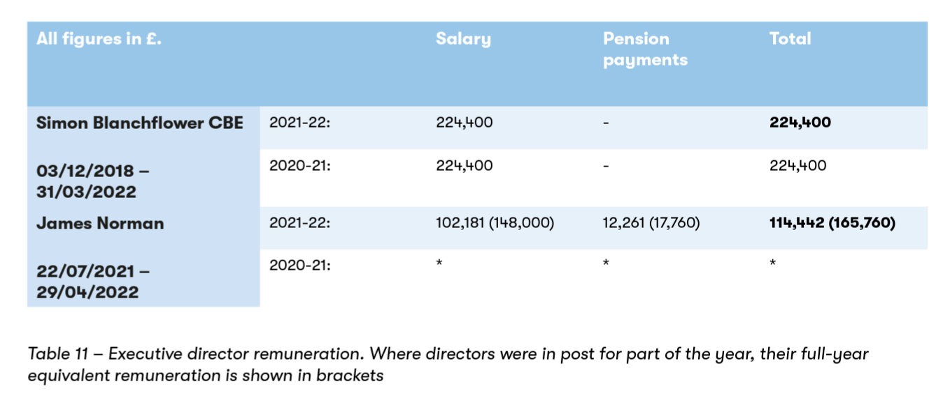

*This is not required as James was not an Executive Director during 2020- 21.

Neither Executive Director received performance related pay (a bonus) or any taxable benefits.

Non-Executive Director Fees (audited)

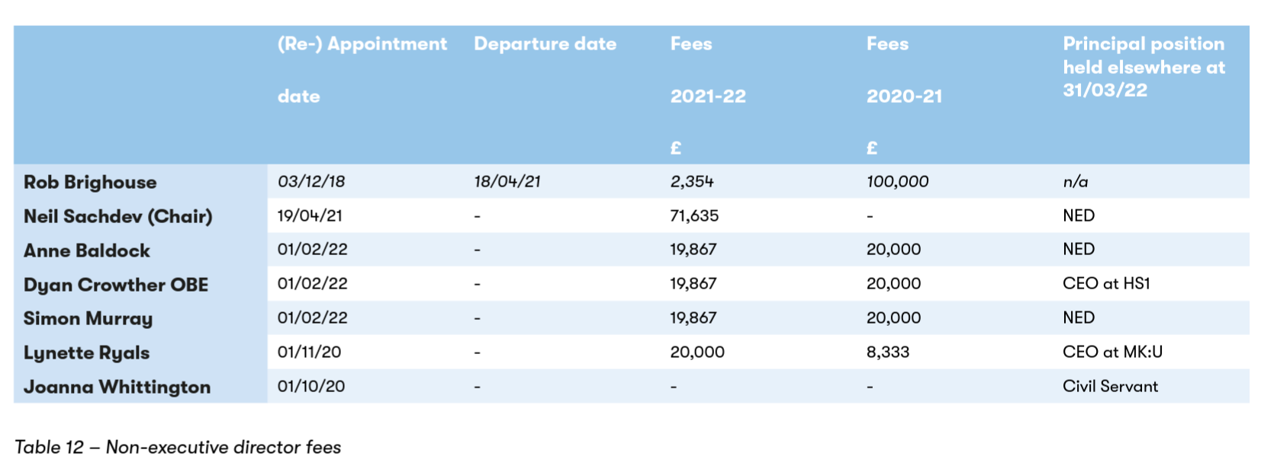
Fees are payable to all NEDs, with the exception of the NED nominated by the Shareholder (Secretary of State). The Shareholder-nominated NED is normally a Civil Servant who receives a salary from the government department that employs them. Joanne Whittington (from the Department for Business, Energy and Industrial Strategy) has been the shareholder- nominated NED since October 2020.

The level of remuneration paid by EWR Co to the non-governmental NEDs reflects the time commitment and responsibilities of the role.

The NEDs re-appointed on 1 February 2022 accepted new terms of appointment. They receive a fee of £19,200 pa, which includes remuneration for chairing a committee. Under the previous terms of appointment, NEDs received a fee of £15,000 pa plus an additional £5,000 pa for chairing a sub-committee.

Our new Chair, Neil Sachdev, is paid £75,000 pa for 2 days per week. Our previous Chair, Rob Brighouse, was paid £100,000 pa for 1.5 days per week.

  - Consultants
EWR Co uses consultancy services on a day-to-day basis. Consultancy is the provision of objective advice relating to strategy, structure, management or operations of an organisation in pursuit of its purposes and objectives. Such advice is provided outside the business-as-usual environment when in-house skills are not available and will be time- limited. Consultancy may include the identification of options with recommendations, or assistance with (but not the delivery of) the implementation of solutions.

Total expenditure made to external consultants during the financial year amounted to £11,937k (2020-21: £7,626k).

Off-payroll appointees
As part of the review of tax arrangements of public sector appointees published by the Chief Secretary to HM Treasury in 2012, public bodies were asked to report on their off-payroll engagements. Data on these appointments are set out below. We ensure compliance with the off-payroll (IR35) working rules by hiring consultants through agencies.

31 March 2022 31 March 2021 31 March 2020
Number of existing engagements at the | 28 56 10
reporting date
Of which:
Less than 1 year at the reporting date | 19 47 3
Between 1 and 2 years at the reporting date | 8 4 7
Between 2 and 3 years at the reporting date | 1 5 -

Table 13 – Off-payroll engagements earning £245 per day of greater at the reporting date

2021-22 |  | 2020-21* | 2019-20*
Number of off-payroll workers engaged in the reporting period  Of which:  Number not subject to off-payroll legislation  Number subject to off-payroll legislation and determined in scope of IR35  Number subject to off-payroll legislation and determined as out of scope of IR35  Number of engagements reassessed for compliance or assurance purposes during the year  Of which: Number of engagements that saw a change in IR35 status following reassessment | 118 | 64 | 10
 | 93 | 64 | 10
 | - | - | -
 | - | - | -
 | 25 | - | -
 | - | - | -

Table 14 - All off-payroll workers engaged at any point earning £245 per day or greater during the reporting pe- riod

*The prior year figures have been reclassified in light of new analysis.

2021-22 |  | 2020-21 | 2019-20
Number of off-payroll engagements of board members, and/or, senior officials with significant financial responsibility during the financial year  Total number. of individuals that have been deemed board members, and/or senior officials with significant financial responsibility, during the financial year. This figure includes both on- payroll and off-payroll engagements | - | - | -
 | 6 | 6 | 6

Table 15 – Off-payroll engagements of board members and/or senior officials with significant financial responsi- bility, between 1 April 2021 and 31 March 2022
The People and Remuneration Report is signed by Beth West, Chief Executive and Accounting Officer, on behalf of the EWR Co Board, on 12 December 2022.

9.

Parliamentary accountability
and auditor’s report

Losses and special payments (audited)
Losses may relate to cash and store losses, book-keeping losses, losses arising from a failure to make adequate charge for the use of public property or services, fruitless payments, claims abandoned and frauds. Special payments include extra-contractual, special severance, ex gratia and compensation payments. EWR Co did not incur any losses or special payments during 2020-21 or 2021-22 that need to be disclosed.

Remote contingent liabilities (audited)
Remote contingent liabilities are potential obligations where the likelihood of a transfer of economic benefit in settlement is judged remote. Because of this, they do not meet the IAS 37 (Provisions, Contingent Liabilities and Contingent Assets) criteria for disclosure in the annual accounts but are presented here for transparency purposes.

EWR Co did not expose itself to any remote contingent liabilities during 2020-21 or 2021-22.

Contingent liabilities for which the probability of crystallisation is rated as greater than remote are disclosed in Note 11 in the Annual Accounts, which also shows that EWR Co did not enter into any contingent liabilities during 2020-21 or 2021-22.

The Independent Auditor’s Report to the members of East West Railway Company Limited

Opinion on financial statements
I have audited the financial statements of East West Railway Company Limited for the year ended 31 March 2022 which comprise East West Railway Company Limited’s:
- Statements of Financial Position as at 31 March 2022;
- Statement of Comprehensive Net Expenditure, Statement of Cash Flows and Statement of Changes in Taxpayers’ Equity for the year then ended; and
- the related notes including the significant accounting policies.

The financial reporting framework that has been applied in the preparation of the financial statements is applicable law and UK adopted International Accounting Standards.
In my opinion the financial statements:
    - give a true and fair view of the state of East West Railway Company Limited’s affairs as at 31 March 2022 and its net expenditure for the year then ended; and
    - have been properly prepared in accordance with UK adopted international accounting standards; and

    - have been prepared in accordance with the requirements of the Companies Act 2006.

Opinion on regularity
In my opinion, in all material respects, the income and expenditure recorded in the financial statements have been applied to the purposes intended by Parliament and the financial transactions recorded in the financial statements conform to the authorities which govern them.

Basis for opinions
I conducted my audit in accordance with International Standards on Auditing (ISAs) (UK), applicable law and Practice Note 10 Audit of Financial Statements of Public Sector Entities in the United Kingdom. My responsibilities under those standards are further described in the Auditor’s responsibilities for the audit of the financial statements section of my report.

Those standards require me and my staff to comply with the Financial Reporting Council’s Revised Ethical Standard 2019. I have also elected to apply the ethical standards relevant to listed entities. I am independent of East West Railway Company Limited in accordance with the ethical requirements that are relevant to my audit of the financial statements in the UK. My staff and I have fulfilled our other ethical responsibilities in accordance with these requirements.

I believe that the audit evidence I have obtained is sufficient and appropriate to provide a basis for my opinion.

Conclusions relating to going concern
In auditing the financial statements, I have concluded that East West Railway Company Limited’s use of the going concern basis of accounting in the preparation of the financial statements is appropriate.

Based on the work I have performed, I have not identified any material uncertainties relating to events or conditions that, individually or collectively, may cast significant doubt on East West Railway Company Limited’s ability to continue as a going concern for a period of at least twelve months from when the financial statements are authorised for issue.

My responsibilities and the responsibilities of the directors with respect to going concern are described in the relevant sections of this report.

Other Information
The other information comprises information included in the Annual Report, but does not include the financial statements and my auditor’s report thereon. The directors are responsible for the other information.

My opinion on the financial statements does not cover the other information and except to the extent otherwise explicitly stated in my report, I do not express any form of assurance conclusion thereon.

In connection with my audit of the financial statements, my responsibility is to read the other information and, in doing so, consider whether the other information is materially inconsistent with the financial statements or my knowledge obtained in the audit or otherwise appears to be materially misstated.

If I identify such material inconsistencies or apparent material misstatements, I am required to determine whether this gives rise to a material misstatement in the financial statements themselves. If, based on the work I have performed, I conclude that there is a material misstatement of this other information, I am required to report that fact.

I have nothing to report in this regard.

Opinion on other matters prescribed by the Companies Act 2006
In my opinion the part of the Directors’ Remuneration Report to be audited has been properly prepared in accordance with the requirements of HM Treasury’s Financial Reporting Manual.

In my opinion, based on the work undertaken in the course of the audit:
- the Strategic Report and the Directors’ Report been prepared in accordance with applicable legal requirements; and
- the information given in the Strategic Report and the Directors’ Report for the financial year for which the financial statements are prepared is consistent with the financial statements.

Matters on which I report by exception
In the light of the knowledge and understanding of East West Railway Company Limited and its environment obtained in the course of the audit, I have not identified material misstatements in the Strategic Report or the Directors’ Report.

I have nothing to report in respect of the following matters in relation to which the Companies Act 2006 requires me to report to you if, in my opinion:
- adequate accounting records have not been kept or returns adequate for my audit have not been received from branches not visited by my staff; or
- the financial statements and the parts of the People and Remuneration Report to be audited are not in agreement with the accounting records and returns; or
- certain disclosures of director’s remuneration specified by law are not made; or
- a corporate governance statement has not been prepared by the parent company; or
- I have not received all of the information and explanations I require for my audit.

Responsibilities of the directors for the financial statements
As explained more fully in the Statement of Directors’ and Accounting Officer’s Responsibilities, the directors are responsible for:
- the preparation of the financial statements in accordance with the applicable financial reporting framework and for being satisfied that they give a true and fair view;
- internal controls as directors determine are necessary to enable the preparation of financial statement to be free from material misstatement, whether due to fraud or error; and
- assessing East West Railway Company Limited’s ability to continue as a going concern, disclosing, as applicable, matters related to going concern and using the going concern basis of accounting unless the directors either intends to liquidate the entity or to cease operations, or has no realistic alternative but to do so.

Auditor’s responsibilities for the audit of the financial statements

My responsibility is to audit and report on the financial statements in accordance with applicable law and International Standards on Auditing (ISAs) (UK).
My objectives are to obtain reasonable assurance about whether the financial statements as a whole are free from material misstatement, whether due to fraud or error, and to issue a report that includes my opinion. Reasonable assurance is a high level of assurance but is not a guarantee that an audit conducted in accordance with ISAs (UK) will always detect a material misstatement when it exists. Misstatements

can arise from fraud or error and are considered material if, individually or in the aggregate, they could reasonably be expected to influence the economic decisions of users taken on the basis of these financial statements.

Extent to which the audit was considered capable of detecting non-compliance with laws and regulations including fraud

I design procedures in line with my responsibilities, outlined above, to detect material misstatements in respect of non-compliance with laws and regulations, including fraud. The extent to which my procedures are capable of detecting non-compliance with laws and regulations, including fraud is detailed below.

Identifying and assessing potential risks related to non- compliance with laws and regulations, including fraud

In identifying and assessing risks of material misstatement in respect of non-compliance with laws and regulations, including fraud, we considered the following:

- the nature of the sector, control environment and operational performance including the design of East West Railway Company Limited’s accounting policies, key performance indicators and performance incentives;
- inquiring of management, East West Railway Company Limited’s head of internal audit and those charged with governance, including obtaining and reviewing supporting documentation relating to East West Railway Company Limited’s policies and procedures relating to
  - identifying, evaluating and complying with laws and regulations and whether they were aware of any instances of non-compliance,
  - detecting and responding to the risks of fraud and whether they have knowledge of any actual, suspected or alleged fraud, and
  - the internal controls established to mitigate risks related to fraud or non-compliance with laws and regulations including East West Railway Company Limited’s controls relating to East West Railway Company Limited’s compliance with the Companies Act 2006 and Managing Public Money;
- discussing among the engagement team regarding how and where fraud might occur in the financial statements and any potential indicators of fraud.

As a result of these procedures, I considered the opportunities and incentives that may exist within East West Railway Company Limited for fraud and identified the greatest potential for fraud in the following areas: posting of unusual journals, complex transactions, and bias in management estimates. In common with all audits under ISAs (UK), I am also required to perform specific procedures to respond to the risk of management override of controls.

I also obtained an understanding of East West Railway Company Limited’s framework of authority as well as other legal and regulatory frameworks in which East West Railway Company Limited operates, focusing on those laws and regulations that had a direct effect on material amounts and disclosures in the financial statements or that had a fundamental effect on the operations of East West Railway Company Limited. The key laws and regulations I considered in this context included the Companies Act 2006, Managing Public Money, employment and tax law.

Audit response to identified risk

As a result of performing the above, the procedures I implemented to respond to identified risks included the following:

- reviewing the financial statement disclosures and testing to supporting documentation to assess compliance with provisions of relevant laws and regulations described above as having direct effect on the financial statements;
- enquiring of management and the Audit and Risk Committee concerning actual and potential litigation and claims;
- reading and reviewing minutes of meetings of those charged with governance and the Board and internal audit reports;
- in addressing the risk of fraud through management override of controls, testing the appropriateness of journal entries and other adjustments; assessing whether the judgements made in making accounting estimates are indicative of a potential bias; and evaluating the business rationale of any significant transactions that are unusual or outside the normal course of business.

I also communicated relevant identified laws and regulations and potential fraud risks to all engagement team members and remained alert to any indications of fraud or non-compliance with laws and regulations throughout the audit.

A further description of my responsibilities for the audit of the financial statements is located on the Financial Reporting Council’s website at: www. frc.org.uk/auditorsresponsibilities. This description forms part of my report.

Other auditor’s responsibilities
I am required to obtain evidence sufficient to give reasonable assurance that the income and expenditure reported in the financial statements have been applied to the purposes intended by Parliament and the financial transactions conform to the authorities which govern them.

I communicate with those charged with governance regarding, among other matters, the planned scope and timing of the audit and significant audit findings, including any significant deficiencies in internal control that I identify during my audit.

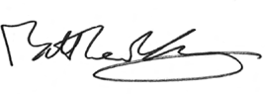

Matthew Kay (Senior Statutory Auditor)
13 December 2022
For and on behalf of the

Comptroller and Auditor General (Statutory Auditor)
National Audit Office
157-197 Buckingham Palace Road Victoria
London SW1W 9SP

10.

Financial Statements for the
year ending 31 March 2022

Statement of comprehensive net expenditure

All values in £000 | Note | 2021-22 | 2020-21
Staff costs | 3 | 20,098 | 12,677
Other expenditure | 4 | 53,463 | 22,496
Depreciation | 4 | 847 | 452
Finance expense | 4 | 12 | 11
Net expenditure for the year |  | 74,420 | 35,636
Comprehensive net expenditure for the year |  | 74,420 | 35,636

The Notes on pages 97 to 111 form part of these financial statements.

Statement of financial position

All values in £000 Note | 31 March 2022 | 31 March 2021
Non-current assets
Property, plant and equipment 5 | 1,544 | 1,939
Right of use assets 6.1 | 423 | 566
Total non-current assets | 1,967 | 2,505
Current assets
Trade and other receivables 7 | 2,399 | 1,352
Cash and cash equivalents | 196 | 241
Total current assets | 2,595 | 1,593
Total assets | 4,562 | 4,098
Current liabilities
Trade and other payables 8 | 9,314 | 5,413
Lease liabilities 6.2 | 173 | 162
Total current liabilities | 9,487 | 5,575
Non-current liabilities
Lease liabilities 6.2 | 323 | 501
Total net assets/ (liabilities) | (5,248) | (1,978)
Taxpayers’ equity
General Fund | (5,248) | (1,978)

The Notes on pages 97 to 111 form part of these financial statements.

The financial statements were approved by the Board on 12 December 2022 and were signed on its behalf by
Beth West

CEO & Accounting Officer

Registered company: 11072935

Statement of cash flows

All values in £000 Note | 2021-22 | 2020-21
Cash flows from operating activities
Net expenditure for the year SOCNE | (74,420) | (35,636)
(Increase) / decrease in trade and other receivables 7 | (1,047) | (985)
Increase / (decrease) in trade and other payables 8 | 3,901 | 198
Depreciation 4 | 847 | 452
Loss on disposal of fixed assets 4 | 2 | -
Other (non-cash) costs 4 | 4 | -
Net cash outflow from operating activities | (70,713) | (35,971)
Cash flows from investing activities
Purchase of property, plant and equipment 5 | (311) | (1,640)
Net cash outflow from investing activities | (311) | (1,640)
Cash flows from financing activities
Capital Contribution from Shareholder SOCTE | 71,150 | 36,850
Payment of leasing liabilities | (177) | (92)
Lease interest 6.2 | 6 | 11
Net cash inflow from financing activities | 70,979 | 36,769
Net increase / (decrease) in cash & cash equivalents | (45) | (842)
Cash & cash equivalents at the beginning of the year | 241 | 1,083
Cash & cash equivalents at the end of the year | 196 | 241

The Notes on pages 97 to 111 form part of these financial statements.

Statement of changes in taxpayers’ equity

All values in £000 | General Fund
Balance at 31 March 2020 | (3,192)
Net expenditure for the year | (35,636)
Capital Contribution from Shareholder | 36,850
Balance at 31 March 2021 | (1,978)
Net expenditure for the year | (74,420)
Capital Contribution from Shareholder | 71,150
Balance at 31 March 2022 | (5,248)

The General Fund serves as the chief operating fund. There are currently no other reserves for the Company.
The Notes on pages 97 to 111 form part of these financial statements.

Notes to the financial statements
Notes to the financial statements provide additional information required by statute and accounting standards to explain a particular feature of the financial statements. The Notes which follow will also provide explanations and additional disclosure to assist readers’ understanding and interpretation of the financial statements and expand upon the accounting policies in Note 1.

General information
East West Railway Company Limited (the Company) is a private company limited by shares (company registration number 11072935), domiciled in the United Kingdom and registered in England and Wales under the Companies Act 2006. The Secretary of State for Transport is the registered holder of the single ordinary share, fully paid. The ultimate controlling party is considered to be the Secretary of State for Transport.

The Company’s principal activities are to develop proposals, design, build and operate a railway network between Oxford and Cambridge.

The Company’s registered office, since 8 July 2021, and principal place of business is One Grafton Mews, Midsummer Boulevard, Milton Keynes, MK9 1FB.

These financial statements cover the 12 months to 31 March 2022.

Note 1: Statement of significant accounting policies
This Note sets out the accounting policies that determine the recognition and valuation of material assets, liabilities, income and expenditure.

Disclosures of critical judgements, accounting estimates and sources of estimation uncertainty are presented within each accounting policy note.

Basis of preparation

These financial statements have been prepared in accordance with the International Financial Reporting Standard’s (IFRSs) and the International Financial Reporting Interpretations Committee’s (IFRIC) interpretations, and with the requirements of the Companies Act 2006 applicable to companies reporting under IFRSs. As a Non-Departmental Public Body (NDPB) and as specified in the framework agreement with DfT, the Company also adopts the interpretations of IFRS and additional disclosure requirements contained in the Government Financial Reporting Manual (FReM) for 2021- 22, where these are compatible with the requirements of the Companies Act.

Where this framework permits a choice of policy, the accounting policy judged to be most appropriate to the particular circumstances of the Company for the purpose of giving a true and fair view has been selected. The particular policies adopted by the Company are described below and have been applied consistently in dealing with matters considered material to the accounts.

Going concern
Directors are content in their view that the Company is a going concern. The basis for this can be reviewed in Section 3.10 of the Strategic Report.

Measurement convention
These accounts have been prepared under the historical cost convention, except where specific departures, including fair value are described.

Historical cost is a measure in which the value of an asset on the balance sheet is recorded at its original cost when acquired by the company. In subsequent periods, that recorded cost is not updated for any increase in prices, although it may be for falls in value.

Estimation techniques used and changes in accounting estimates

The recognition and valuation of accrued expenditure, where specific information is not available, is based on the Company’s best estimate of the cost. For consultant expenditure, this is based on the Company’s knowledge of time worked and rates agreed in advance. Where invoices differ from the estimates made, the difference is credited back to the relevant service.

Financing
The Company is funded by capital contributions from the DfT, representing the Secretary of State as its sole controlling party. In line with IAS 1, since these contributions are made by the Secretary of State in their capacity as an owner, capital contributions from the Shareholder are presented directly in reserves (equity) rather than as income.

Funding from the DfT is recognised when the cash is received.

Property, plant and equipment Recognition:
Expenditure on the acquisition, creation or enhancement of property, plant and equipment is capitalised on an accruals basis, provided that it is probable that the useful economic life (UEL), including service potential, associated with the item will flow to the Company and the cost of the item can be measured reliably. Assets are held as assets under construction until the point at which the asset is brought into service.

A capitalisation threshold of £1,000 is applied to all asset classes. Expenditure below this value is charged as an expense in the Statement of Changes in Net Expenditure (SoCNE).

Property, plant and equipment is based on the identification of single assets with a threshold value greater than £1,000. Where an item includes material components with a significantly different UEL, those components are capitalised separately and depreciated over their specific UEL.

Expenditure that maintains but does not add to an asset’s potential to deliver future economic benefits or service potential (i.e. repairs and maintenance) is charged as an expense as incurred.

Measurement:
Property, plant and equipment, including assets under construction are valued in accordance with IAS 16 Property, Plant and Equipment and initially measured at cost, comprising:
- The purchase price;
- Any costs attributable to bringing the asset to the location and condition necessary for it to be capable of operating in the same manner intended by management; and
- The initial estimate of the costs of dismantling and removing the item and restoring the site on which it is located where an obligation to dismantle or remove the asset arises from its acquisition or usage.
- Assets are thereafter carried in the balance sheet using the following measurement basis: all property, plant and equipment are valued on the basis of depreciated historic cost as an approximation of fair value.

Impairment:
Property, plant and equipment are monitored throughout the year as to whether there is any indication that an asset may be impaired.

Where indications exist and any possible differences are estimated to be material, the recoverable amount of the asset is estimated and, where this is less than the carrying amount of the asset, an impairment loss is recognised in the SoCNE.

Where an impairment loss is subsequently reversed, the reversal is credited in the SoCNE, up to the amount of the original loss, adjusted for depreciation that would have been charged if the loss had not been recognised.

Depreciation:
Depreciation is provided on all non-current assets, apart from assets under construction, from the date at which they are available for their
intended use at rates calculated to write off the cost of each asset (less any estimated residual value) on a straight-line basis over its UEL; see below.
Assets that are under construction are not depreciated until such time as they are available for their intended use.

Asset class | Depreciation method | Depreciation rate
Computing equipment Fixtures and fittings  Right of use (leases) | Straight line | 36 months
 | Straight line | The remaining term of the lease at the point that the assets came into use, or 36 months as appropriate
 | Straight line | Term of lease
The Company reviews and updates the remaining UEL of all its assets each year. This is the period for which the asset provides economic benefits that will flow to the Company from its use.

Disposals:
When scrapping or disposing of a property, plant and equipment asset, the carrying amount is written off to the SoCNE and a loss (or gain) is recognised and reported net of any disposal proceeds.

Leases

Scope and classification:
In accordance with IFRS 16, contracts, or parts of a contract that convey the right to use an asset in exchange for consideration are accounted for as leases. The Company also applies the standard to arrangements with other government departments which share accommodation. Contracts for services are evaluated to determine whether they convey the right to control the use of an identified asset, as represented by rights both to obtain substantially all the economic benefits from that asset and to direct its use. In such cases, the relevant part is treated as a lease.

The Company excludes contracts for low-value items, defined as items costing less than £5,000 when new, provided they are not highly dependent on or integrated with other items; and contracts with a term shorter than twelve months (comprising the non-cancellable period together with any extension options that the Company is reasonably certain to exercise and any termination options that the Company is reasonably certain not to exercise).

Initial recognition:
At the commencement of a lease (or the IFRS 16 transition date, if later), the Company recognises a right-of-use asset and a lease liability.

The lease liability is measured at the payments, net of value added tax, for the remaining lease term (as defined above), discounted either by the rate implicit in the lease, or, where this cannot be determined, the Companies incremental cost of borrowing. The payments included in the liability are those that are fixed or in-substance fixed, excluding changes arising, for example, from future rent reviews or changes in an index. The Company does not undertake external borrowing and is instead funded annually by the DfT which draws down its funding from the Exchequer. The Company’s incremental borrowing rate is therefore advised by and aligned to HM Treasury’s rate.

The right-of-use asset is measured at the value of the liability, adjusted for: any payments made before the commencement date; lease incentives received; incremental costs of obtaining the lease; and any disposal costs at the end of the lease.

Subsequent measurement:
The asset is subsequently measured using the fair value model. The Company considers that the cost model is a reasonable proxy for the fair value model for leases of items other than land and property, and for
leases of land and property with regular rent reviews. For other leases, the asset is carried at a revalued amount.

The liability is adjusted for the accrual of interest, repayments, reassessments and modifications. Reassessments and modifications are measured by re-discounting the revised cash flows; the impact is reflected in the liability and either in the asset valuation or expenditure as follows:

Scenario  Reassessment | Discount rate | Asset or expenditure
The Company becomes or ceases to be reasonably certain to exercise an extension or termination option, due to a significant event or change in circumstances | Revised | Asset*
The non-cancellable period changes | Revised | Asset*
The amount payable under a residual value guarantee changes | Original | Asset*
There is a movement in an index or rate that will alter the cash flows (except for floating-rate arrangements) | Original | Asset*  (with an adjustment to any revaluation surplus where a change in the liability has already been reflected in the value of the asset)
There is a change in the variable lease payments, that was not included in the measurement of the lease payments during the period in which the triggering event occurred | Original | Expenditure
Modification
Other leased assets are included, priced on a standalone basis | New | Asset  (this is presented as the creation of new right-of-use assets and lease liabilities, discounted by a new rate)
The scope is decreased | Revised | Asset and Expenditure  (the asset is remeasured proportionate to the reduction in scope; any difference between the change in the value of the asset and liability is recognised as a gain or loss)
The lease term is increased | Revised | Asset*
The consideration is changed | Revised | Asset*
* Where the amount of a reduction to the asset exceeds the carrying value of the asset, the excess amount is recognised in expenditure.

Lease expenditure:
Expenditure includes interest, straight-line depreciation, any asset impairments and any change in variable lease payments not included in the measurement of the liability during the period in which the triggering event occurred. Lease payments are debited against the liability. Rental payments for leases of low-value items or for those shorter than twelve months are expensed.

Cash and cash equivalents
Cash and cash equivalents comprise bank balances held with the Government Banking Service.

Financial liabilities
Financial liabilities are any contractual obligations to deliver cash or other financial assets to a third-party including trade and other payables (current and non-current). The Company values liabilities initially at fair value: the transaction value is considered to be the fair value at the date of recognition. Thereafter, where the time value of money is considered to be material, they are held at amortised cost using the effective interest rate to discount cash flows. Derecognition (i.e. removal from the financial statements) occurs when the liability has been settled.

Provisions and contingent liabilities
The Company recognises provisions when it has a legal or constructive obligation arising from a past event, the transfer of economic benefits is probable, and a reasonable estimate can be made. Provisions are charged to the Statement of Comprehensive Net Expenditure unless they relate to capital projects. In which case, the provision is added to the assets carrying amount. Where the effect of the time value of money is material, the estimated risk-adjusted cash flows are discounted using the rates set by HM Treasury. When the discount is unwound, the adjustment is recognised as an interest expense. If the amount of a present obligation cannot be estimated reliably, the obligation is disclosed as a contingent liability.

The Company discloses potential future obligations arising from past obligating events as contingent liabilities, where their existence remains uncertain pending the outcome of future events outside of its control.

Contingent liabilities whose likelihood is other than remote are disclosed in Note 11 as required by IAS 37. Remote contingent liabilities are disclosed in the Accountability Report to ensure that Parliament remains aware of all arrangements that may require funding. These include guarantees, indemnities and letters of comfort reported to Parliament in accordance with Managing Public Money. Where the time value of money is material, contingent liabilities are stated at discounted amounts.

Employee benefits
Wages and salaries includes gross salaries, performance pay or bonuses, overtime, recruitment and retention allowances, ex-gratia payments and any other taxable allowances or payments, as well as costs relating to agency, temporary and contract staff engaged by the company on a contract to undertake a project or task.

Salaries, wages and employment-related payments are recognised in the period in which the service is received from employees.

Performance-related bonuses:
At the year end, each employee’s performance has not been formally assessed and consequently the pay increases and bonus payments for the year to 31 March are not yet known. However, the work has been completed and therefore a liability is created. The value of the bonuses to be paid is estimated and accrued based on all information that is available including: Company performance forecasts, previous employee performances and performance related pay scheme details. This is aligned to accounting standard IAS 19 Employee Benefits.

Holiday pay:
Employees of the Company have different holiday leave year end dates based upon their date of employment. As leave is used during the year at different times compared to a straight-line accrual, at 31 March there is an element of leave that is owed either by the company to employees or owed by employees to the company. The cost of leave earned but not taken by employees is recognised in the financial statements.

Pensions:
The Company’s staff may participate in a Stakeholder (defined contribution) pension scheme, which became operational in April 2019.

Seconded staff may be members of a scheme operated by their host organisation. The Company’s responsibility for seconded staff’s pension contributions is limited to the periodic recharge by the host organisation for the cost of the seconded staff’s time. As a consequence of these arrangements, pension liabilities do not rest with the Company for seconded staff.

Corporation Tax
The Company is registered for Corporation Tax. By using the tax rates that have been enacted or substantively enacted at the balance-sheet date, the Company has not incurred any tax liability during this reporting period.

Value Added Tax
Many of the activities of the Company are non-business in nature and, for this reason, outside the scope of VAT. The Company is eligible under section 41 (3) of the VAT Act 1994 to recover input VAT which is recovered under an annual HM Treasury Direction. Irrecoverable VAT is charged to the relevant expenditure category or included in the capitalised purchase cost of non- current assets. Where output tax is charged or input VAT is recoverable, the amounts are stated net of VAT.

Related party transactions
The Company is an Executive Non-Departmental Public Body sponsored by the DfT, which accordingly is a related party.

Note 2: Statement of expenditure by operating segment
Further information about these segments can be found in Section 3.3 of the Strategic Report; the smaller cross-cutting functions are consolidated into Corporate Services.

All values are in £000 | Capital expenditure | Resource expenditure | 2021-22  Total
Delivery | - | 36,672 | 36,672
Corporate Services | 311 | 12,861 | 13,172
Strategy | - | 12,969 | 12,969
Engineering | - | 8,487 | 8,487
Customer Services | - | 2,584 | 2,584
Depreciation | - | 847 | 847
Total net expenditure | 311 | 74,420 | 74,731
Of which:
Programme costs | 311 | 74,249 | 74,560
Administration costs | - | 171 | 171
Total net expenditure | 311 | 74,420 | 74,731

The Board considers capital spending and liabilities by monitoring outturn against the budgetary control totals; for example, PPE additions score against the capital. As a consequence, the Company did not report asset and liability balances on an IFRS-basis to the Board.

Note 3: Staff costs
Information on staff numbers, exit packages and other relevant disclosures, is included in the People and Remuneration Report in Section 8.

All values in £000 | Permanently employed  staff | Other staff | 2021-22  Total | 2020-21  Total
Wages and salaries | 8,607 | 9,356 | 17,963 | 11,315
Social security costs | 1,039 | - | 1,039 | 644
Pension costs | 925 | - | 925 | 532
Non-executive director fees | 171 | - | 171 | 186
Total staff costs | 10,742 | 9,356 | 20,098 | 12,677

Other staff costs include costs for contractors and secondees.
Non-executive director fees include employer’s pension contributions.
The key management personnel in 2021-22 were the Chief Executive Officer and Corporate Services Director and in 2020-21 the key management personnel were the Chief Executive Officer and the chair of the board of directors. Full details of their remuneration are included within the People and Remuneration Report in Section 8.

Note 4: Other expenditure

All values in £000 Note | 2021-22 | 2020-21
Non-staff expenditure includes:
Professional services | 30,796 | 9,413
Consultancy services | 11,937 | 7,454
Communications & publicity | 3,110 | 864
Information & communications technology | 2,627 | 1,769
Legal | 1,941 | 836
Licence & agent fees | 1,011 | 723
Recruitment fees | 477 | 186
Training & education | 376 | 313
Accommodation & office services | 254 | 394
Insurance | 177 | 24
External audit fee (inc. VAT) | 86 | 78
Internal audit fee | 48 | 40
Travel & subsistence | 24 | 9
Other | 599 | 393
 | 53,463 | 22,496
Depreciation
Depreciation of tangible assets 5 | 704 | 310
Depreciation of right of use assets 6.1 | 143 | 142
 | 847 | 452
Other non-cash costs
Lease interest 6.2 | 6 | 11
Loss on disposal 5 | 2 | -
Other | 4 | -
 | 12 | 11
Total other expenditure | 54,322 | 22,959

Note 5: Property, plant and equipment

All values in £000  Year ended 31 March 2022 | Assets under construction | Fixtures & fittings | Information technology | Total
Cost or valuation
At 1 April 2021 | - | 1,710 | 605 | 2,315
Additions | - | 4 | 307 | 311
Disposal | - | (4) | (3) | (7)
At 31 March 2022 | - | 1,710 | 909 | 2,619
Depreciation
At 1 April 2021 | - | 172 | 204 | 376
Charged in year | - | 403 | 301 | 704
Disposal | - | (2) | (3) | (5)
At 31 March 2022 | - | 573 | 502 | 1,075
Net book value at 31 March 2021 | - | 1,538 | 401 | 1,939
Net book value at 31 March 2022 | - | 1,137 | 407 | 1,544

Year ended 31 March 2021 | Assets under  construction | Fixtures &  fittings | Information  technology | Total
Cost or valuation
At 1 April 2020 | 479 | 4 | 192 | 675
Additions | 1,227 | - | 413 | 1,640
Reclassification | (1,706) | 1,706 | - | -
At 31 March 2021 | - | 1,710 | 605 | 2,315
Depreciation
At 1 April 2020 | - | 1 | 65 | 66
Charged in year | - | 171 | 139 | 310
At 31 March 2021 | - | 172 | 204 | 376
Net book value at 31 March 2020 | 479 | 3 | 127 | 609
Net book value at 31 March 2021 | - | 1,538 | 401 | 1,939
The Company owns all of its property, plant and equipment. The assets under construction related to the fit-out of the Company’s leased office in Milton Keynes that became available for use in November 2020.

Note 6.1: Right of use assets
All of the right of use asset balance comprises office accommodation.

Year ended 31 March 2022 | £000
Cost or valuation
At 1 April 2021 | 732
Additions | -
At 31 March 2022 | 732
Depreciation
At 1 April 2021 | 166
Charged in year | 143
At 31 March 2022 | 309
Net book value at 31 March 2021 | 566
Net book value at 31 March 2022 | 423

Year ended 31 March 2021
Cost or valuation At 1 April 2020 | 732
Additions | -
At 31 March 2021 | 732
Depreciation At 1 April 2020 | 24
Charged in year | 142
At 31 March 2021 | 166
Net book value at 31 March 2020 | 708
Net book value at 31 March 2021 | 566

Note 6.2: Lease liabilities

All values in £000 | 31 March 2022 | 31 March 2021
Amounts falling due
Not later than one year | 177 | 168
Later than one year and not later than five years | 328 | 510
 | 505 | 678
Less: Unaccrued interest | (9) | (15)
Balance at year end | 496 | 663
Of which:
Current | 173 | 162
Non-current | 323 | 501
 | 496 | 663
Amounts recognised in expenditure
Depreciation | 142 | 142
Interest expense | 6 | 11
 | 148 | 153

Note 7: Trade receivables and other current assets

All values in £000 and fall due within one year | 31 March 2022 | 31 March 2021
VAT receivable | 1,736 | 901
Prepayments | 655 | 440
Staff travel loans | 8 | 11
 | 2,399 | 1,352
Note 8: Trade payables and other current liabilities

All values in £000 and fall due within one year | 31 March 2022 | 31 March 2021
Trade payables | 242 | 1,425
Staff costs accrual | 1,463 | 645
Accruals | 7,609 | 3,343
 | 9,314 | 5,413
Note 9: Financial Instruments
EWR Co has no borrowings and is funded by capital contribution from the DfT.
The Company aims to maintain minimal holdings of cash appropriate to its short-term needs.

Note 10: Financial commitments
The Company confirms that there were none to disclose as of 31 March 2021 or 2022.

Note 11: Contingent liabilities
The Company confirms that there were none to disclose as of 31 March 2021 or 2022.

Note 12: Related-party transactions
The Company is an Executive Non-Departmental Public Body sponsored by the Department for Transport (DfT), which is a related party. All of the transactions with the DfT are carried out on an arm’s-length basis.

All values in £000 | 2021-22 | 2020-21
Transactions between the Company and DfT  Capital contribution received from DfT | 71,150 | 36,850
Amounts paid to DfT | 188 | 301
Amounts included in Payables at the end of year | - | -

Other than their remuneration disclosed in Sections 8.22 and 8.23 of the People and Remuneration Report, none of the Board members or key management staff has undertaken any material transactions with the Company or its related parties during the year or the previous year, except for Neil Sachdev and Lynette Ryals as disclosed below, and no one has a financial interest in the activities of the Company such as to influence their work with the Company.

All values in £000 | 2021-22 | 2020-21
Relationship: The Company’s Chair, Neil Sachdev, is also a NED for Network Rail’s Property Supervisory Committee.
The Company’s former Chair, Rob Brighouse, was a NED for Network Rail.
Transactions between EWR Co and Network Rail:
Amounts paid to Network Rail | 367 | 226
Amounts included in Payables at the end of year | 622 | 181
These amounts relate to staff seconded from Network Rail to EWR Co.
Relationship: Lynette Ryals, NED, is also Pro-Vice-Chancellor
of Cranfield University.
Transactions between EWR Co and Cranfield University:
Amounts paid to Cranfield University | - | 33
Amounts included in Payables at the end of year | - | 20

Note 13: Post balance sheet events
There have been no events between 31 March 2022 and the date the financial statements were authorised for issue requiring an adjustment to the financial statements.
These financial statements are laid before the Houses of Parliament. The Accounting Officer has authorised these financial statements to be issued on the same day as the signature of the Independent Auditors’ Report.

